

I’m so angry. What should I do?


Bob the Builder Gets Angry

Sometimes Bob the Builder gets angry.

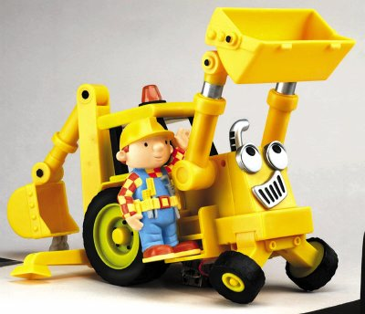
Scoop, I’m so angry. I’m going to hit you.

Sometimes Bob feels like hitting someone.

Don’t hit someone, Bob! That hurts! There are other things to do if you’re angry.

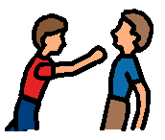 No Hitting!!!

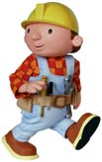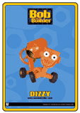

Sometimes Bob gets frustrated. He wants to break something. Don’t break Dizzy the Cement Mixer, Bob! Then you won’t be able to play with it later!!!

There are other things you can do if you are frustrated!!!

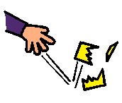 Don’t Break Things!!!

Bob wants to know what to do if he’s angry. He wants to know what to do if he’s frustrated. Bob does not want to hurt anyone. He does not want to break something.
What can I do when I’m angry or frustrated???
Here are some things Bob can do:

- Listen to a tape 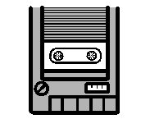
- Squeeze a pillow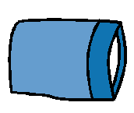
- Draw 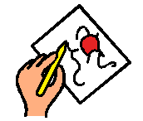
- Sit in the bean bag chair 

Sometimes I feel angry, too. Sometimes I feel frustrated.
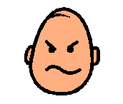Angry??? 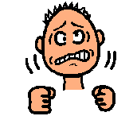Frustrated???

When I feel Angry or Frustrated I will try to remember:

No Hitting!!! Don’t Break Things

I can do other things when I am angry or frustrated. I can:

- Listen to a tape
- Squeeze a pillow
- Draw
- Sit in the bean bag chair

Everyone will be happy when I remember what to do when I am angry or frustrated.

