SELF-CONTROL

What is Self-Control?

Self control means to
Stop 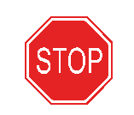 and Think 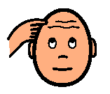

before you do something.

Sometimes I get anxious.
Anxious means worried. When I feel that way I might feel like leaving or hiding.

If someone tries to help me sometimes I just want to push them away or throw something.

When I feel like leaving or pushing or throwing I’m going to STOP and THINK! I can do SELF-CONTROL!!! COOL!

Stop and think! I can hand my “Emergency card”. It says I need to go to my room. It says I need Ms. ____, Mr. ____, or Ms. _____.

Everything can be OK then. I might need to wait with the adult but they will be sure I get to my room.

Hey, I can STOP and THINK – I think I can hand my Emergency Card!

Now I don’t have to leave, I don’t have to hide, I don’t have to push.

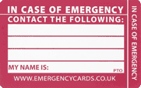
I have SELF-CONTROL CAUSE I HAVE AN EMERGENCY CARD!

