I’m Just Like the Planets!

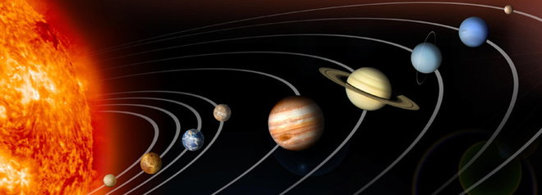
Planets travel around the sun.

I travel to school!!!
Here I go!

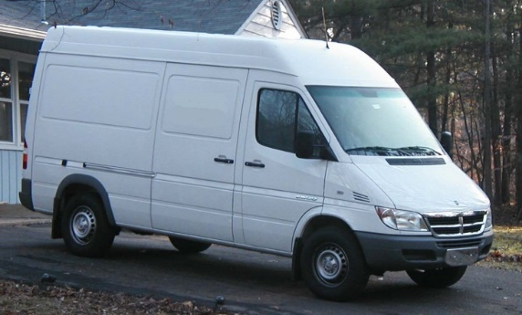

I get on the bus.

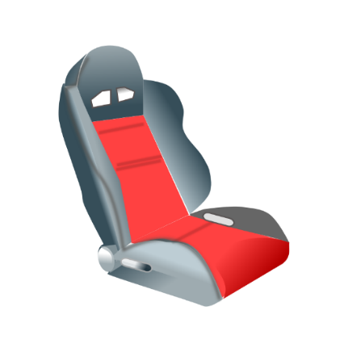

I sit in my seat.
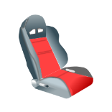

Click! My seatbelt stays on.
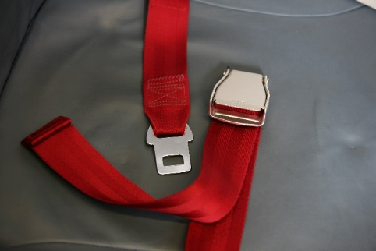

Planets stay where they belong.
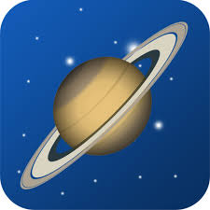

I stay where I belong!
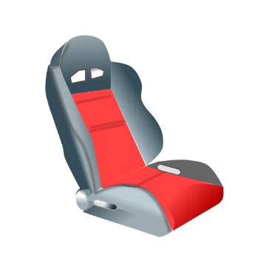

I am at school!!!!!! [Insert photo of school]

Here comes my teacher. [ Insert photo]

I stand up. I get off the bus.
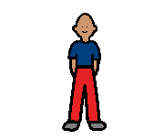
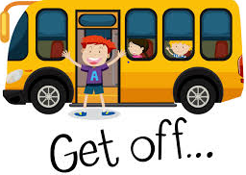
.

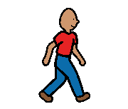
I WALK with my teacher

Here is my room.
[can include photo of room and teachers]

Hi Ms. ________, Hi Ms. ________, Hi friends!

When the day is over I sing the goodbye song.
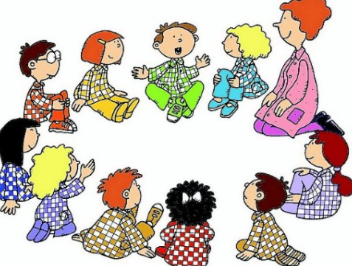

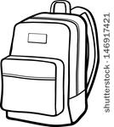
I get my coat and backpack.
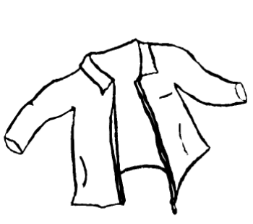

Here I come Mr. [insert Bus driver name]
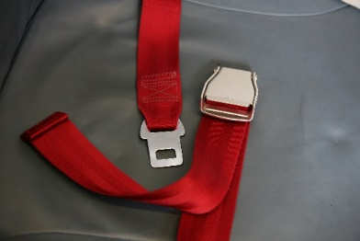

I stay where I belong just like a planet!!

I am home!!! I stand up and walk from the bus to my house!

The planets and I are where we belong!
