When I Raise My Hand

Hello! My name is Bill. I am 11 years old. I am in the 5th grade.

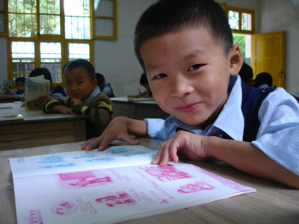

When I am in my classroom, the teacher asks questions. I love to raise my hand to answer questions. I want the teacher to call on me.

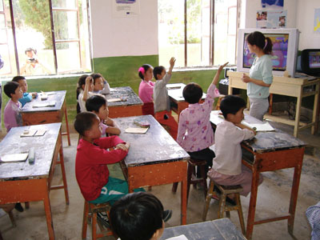

When the teacher wants to give someone a turn, I want the teacher to call on me first!

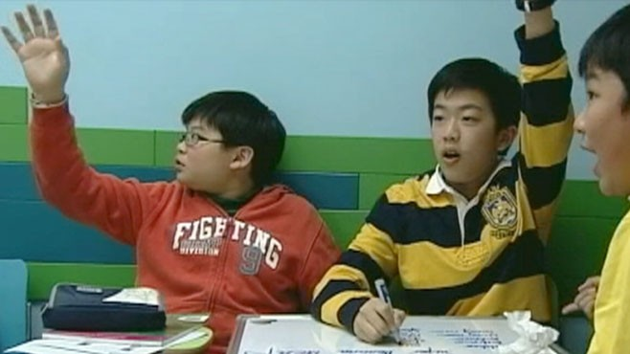
But other students want a turn too! My teacher tries hard to give everyone a turn. Everyone cannot be first.
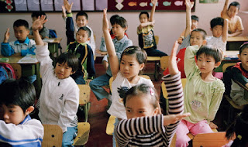
The most important thing is that everyone gets a turn in class. If I am not first, that is OK. The teacher will call on me sometime too.

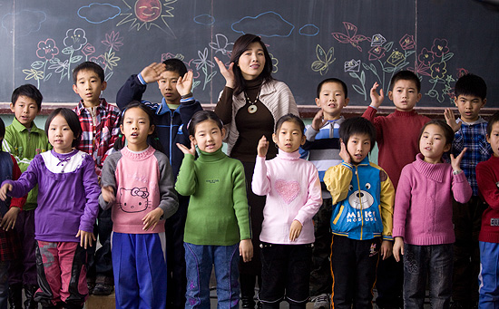

I am going to try to make my teacher happy. I know that she will give me a turn and call on me. I do not have to be first and that is OK! I can wait!

