[Name of your School] Psychologist and her Job
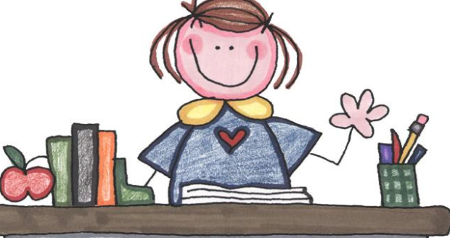
There are many kids at my school, and, there are many adults working here to keep us all happy and safe! One of the adults is the School Psychologist.

At my school the psychologist is [psychologist name].

[Psychologist name] has SO many jobs! Here are a few of them.
She has to test many new students at our school. Then she has to keep testing kids who are already here. The tests help the teachers know how and what to teach the kids.
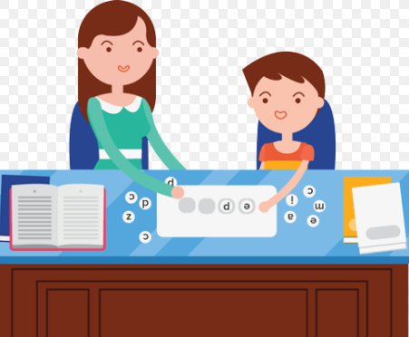

After she does the testing, she then has to write up lots of reports so the teachers can understand what they are going to teach and how to teach kids.
I wanted to let you know the best ways to teach some of your students

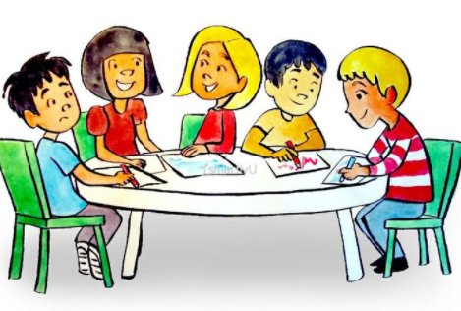
She also does lessons for kids that teach all of us the school behaviors we need to be successful in school and to have friends.

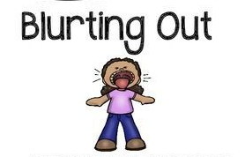
Here are some of the things she might teach kids:
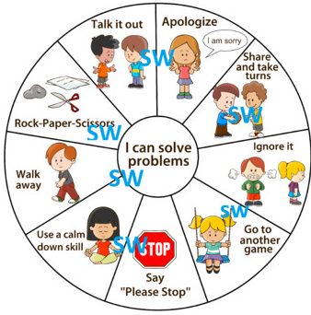
NOT TO
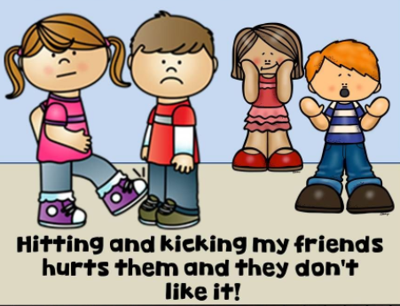

Sometimes she even teaches with the teachers.
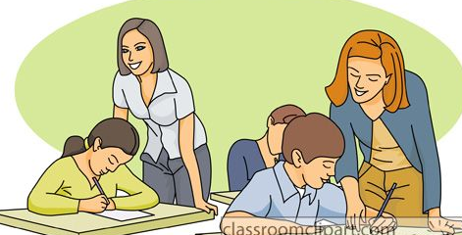

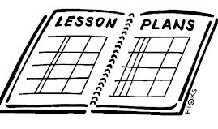
She has to plan the lessons for kids.

She has to schedule times to meet with kids.
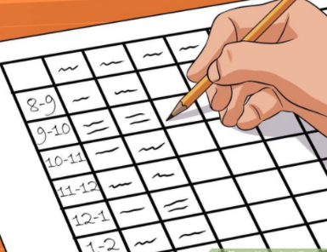

She has to find time to attend meetings with teachers, with administrators, and with families.

She has to drive to preschools to meet kids who might come to [your school name].

She helps kids to feel better if they are having a hard day or if they made decisions that were not the best ones. She is there to help kids.

So sometimes she is just like kids. She can feel frustrated and very tired after all that work.
Kids at school can make their psychologist feel good about her job by letting the psychologist help them, by using words to tell how they feel when upset, and to even let the psychologist know when they are having a great day!
I like [psychologist name] because she teaches us how to act in school and helps us when we feel bad.
I love my job even when I’m tired because the kids let me help them!

