Private Areas – Public and Private
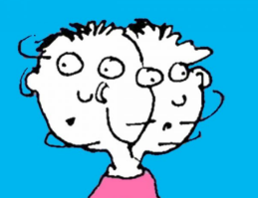
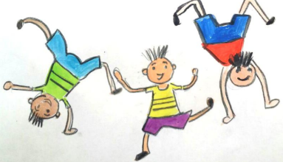
I recently got into some trouble at school. Sometimes my mind just races and my body has to move! Sometimes I do something without thinking it through very well.

I forget what the consequences can be! The trouble I got into was because I touched and, ‘exposed’ my private parts. I did it for real and for pretend. Sometimes I just want to touch, sometimes I think it is funny and just want everyone to laugh.
But people all over the world have rules about doing this behavior. People should only touch private areas when they are in a private place. That is easy to remember… ‘Private in private’. Most places are public – public is where other people are near me or can see me. My classrooms are NOT private places. There are NO private places in SCHOOLS.

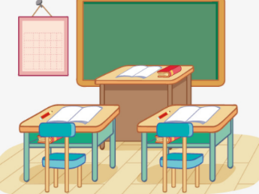

People get upset if they see anyone touch their private areas. People will think I am weird if I do this. I may then be embarrassed. It is NOT okay to touch private areas when people are around.
What is up with [student name]? That is weird. Don’t want to be around him right now!

If I need to touch my private areas I will make sure I’m at home in a private place like the bathroom or my bedroom.
Another scary consequence of ‘exposing’ my privates is that when people grow up they can be arrested for this behavior because it is against the law. So I need to learn now what I can and cannot do.

It’s a good thing that there are adults in school to tell me what is expected of me and what can get me into trouble. That way I will learn now and know what is expected as I grow up. Private = Private
Include pix of school personnel who counsels the student. (teacher, principal, psychologist, counselor)
Good Job [student name]!!

