Other Things I Can Do
My name is [student name]. I go to [student’s school name] School. I have many friends in my class. I am a lot like my friends [peer name], [peer name], [peer name], and [peer name]. We are all in the same room. We like to talk , work, and play together. Here we are working together at school.
Insert picture of student and peers working together

Some things are easy and fun in school. Some things are exciting. Some things are hard.

When I understand what to do in school I get busy and do my work.
Insert picture of student working at his/her desk

Sometimes things are hard. Sometimes it is hard to get started. Sometimes I just get tired. When I’m confused or tired I sometimes make my hands tight. This is sometimes called “hand posturing”.
Insert picture of student engaged in hand posturing

Sometimes I look down when I’m doing hand posturing, then I miss what the teacher is saying. Sometimes I get behind and don’t get the work finished.
Picture of student at desk, head down, engaged in self-stimulatory interfering behaviors

There is good news though. There are things I can do instead of hand posturing when I feel confused or tired. One thing I can do is
squeeze a ‘fidget’.
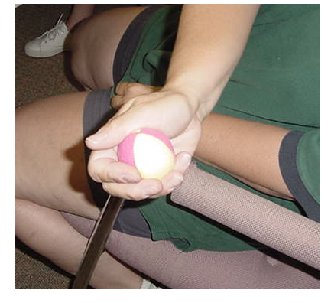

This is really good because I can do my work, listen to my teacher and squeeze at the same time. I could write with one hand and squeeze the fidget with the other.
When I am confused I can raise my hand for help or ask one of my friends to help me. I can do this AND squeeze the fidget.
Insert picture of student raising his/her hand at desk

When I raise my hand I can get help from the teacher or another adult. Here I am getting some help because I raised my hand.
Picture of student at desk with teacher assisting him/her

Another thing I can do when I’m confused is just ask a friend to help me instead of posturing. Here is my friend [peer name] helping me out. Sometimes I can help him too!
Picture of peer assisting student at desk

I can also just squeeze one of my hands or my arm with my other hand instead of hand posturing.

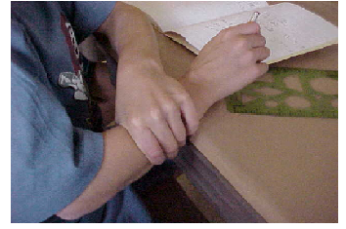
So there are many things I can do when I feel like hand posturing. I can:
- Squeeze a fidget
- Raise my hand for help or ask a friend
- Squeeze my arm

If I try very hard to do other things I will be proud. I will be able to work better and have more fun with my friends.
Insert Picture of Peer Friend

Insert Picture of Peer Friend
Insert Picture of Student

