My Principals: Their Job and How We Talk Together
I go to [ your school name]. There are many kids in my building.
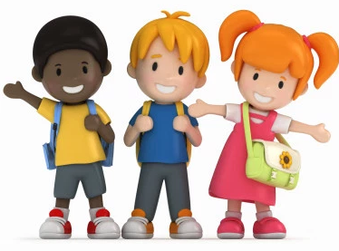

There are also many adults. All of the adults have jobs. This is a story about a Principal’s job.

There are 2 principals at my school. They have many jobs to get done.
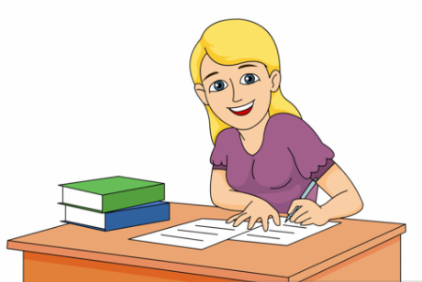

They help teachers make schedules for hundreds of kids!
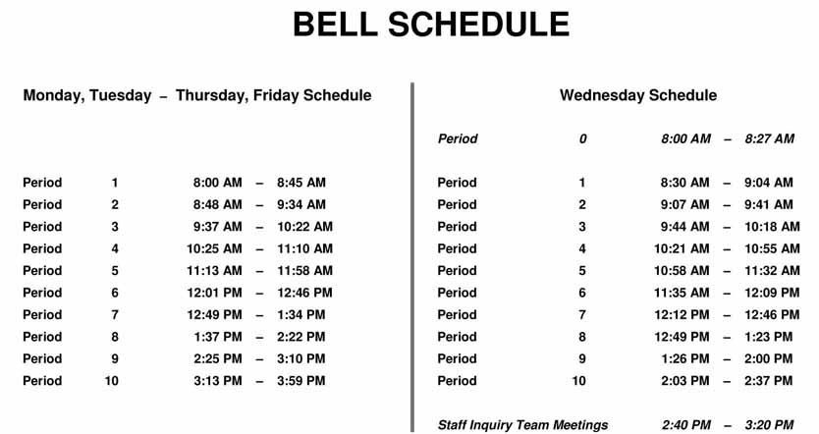

They help order materials for kids.

They have to fill out lots of forms for the school.

They have to give the secretaries work and check on the office.

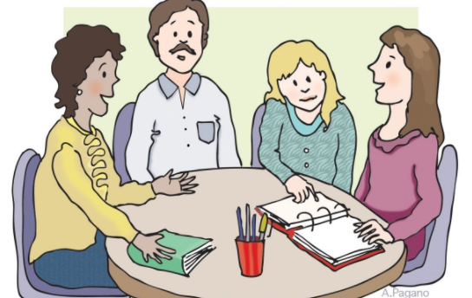
They have to come to meetings – all kinds of meetings. They meet with teachers, families, administrators, and even kids!

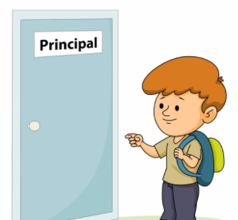
When kids aren’t feeling well or are upset, they help. When kids want to talk about problems, principals want to listen.

Sometimes kids can do things that are not good because they are upset. The principals try very hard to help the kids feel better and do the right things. Their big job is to protect everyone.

With all these jobs even principals can get tired. They don’t have anyone to help them!
I’m exhausted!
So much work to do!!!!!
Kids and principals try hard to talk nice to each other because students and principals have lots of work and can feel upset sometimes. So they all want someone to care.

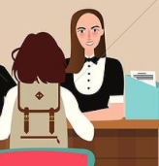
A fun thing to do at school would be to ‘interview’ my principals. I can ask questions, and they can tell me about their jobs.

