My Friend is Having a Rough Day
It is fun to be with my friends at school.
We like to run.
We like to play basketball.

Sometimes it’s even fun to do our work.
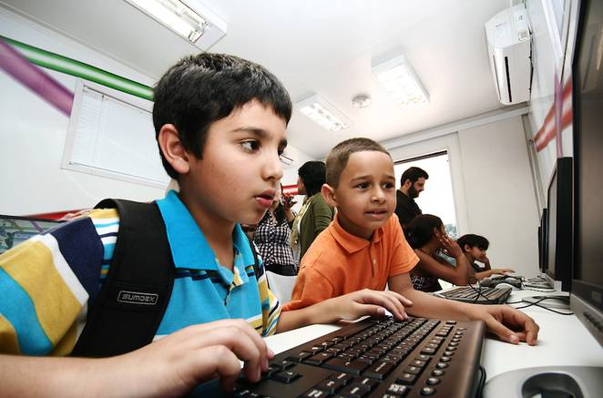
There are many things to do.

But, sometimes my friend has a rough day.
What’s wrong?

Maybe he is sad.

Maybe he is angry.

Maybe he doesn’t feel well.
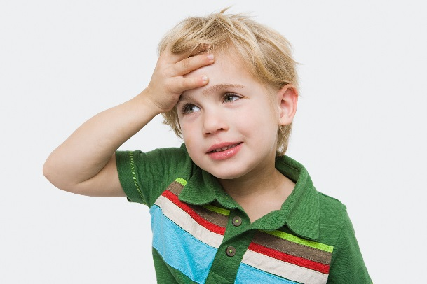

Maybe something happened that she doesn’t want to talk about.
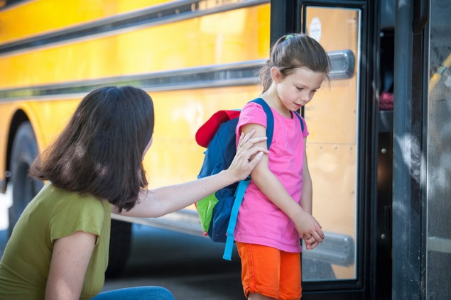

When one of my friends is having a rough day. I can help.

I can talk kindly to him.
I can ask him if there’s anything I can do to help.
Can I help?

If he says yes – I can help him.

But, If he says no – maybe I should just leave her alone.
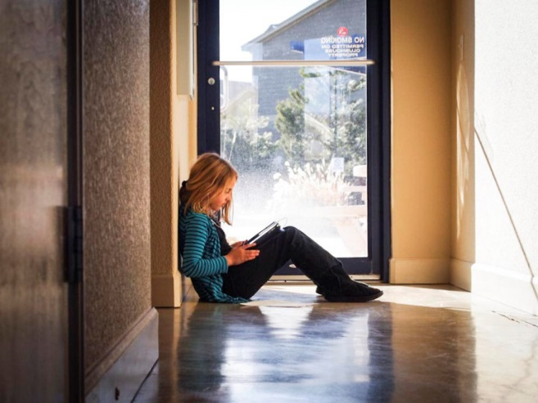
Sometimes it might help if my friend can just have some quiet time.

I will go back to my work.

I will try to ignore the things he is saying. (Remember – IGNORE means – no talking, no teasing, no making faces at, no instigating).

I understand that he doesn’t feel right and might say something he doesn’t really mean.
Tomorrow is another day. We don’t even need to talk about the rough day tomorrow – We can start out fresh. It’s a new day.
