

Watson Takes A Close Look At…

Mini-Schedules

Strategies to increase student independence include the use of schedules. Schedules should answer 4 questions for the student. (Division TEACCH, North Carolina)

What am I expected to do?
How much am I expected to do?
How will I know when I’m finished?
What will I do next?

Classrooms use these questions to provide all day class schedules. But providing schedules WITHIN a task or within a teacher directed time can be a powerful tool to promote positive behaviors including task completion. To better discriminate between types of schedules we will refer to these as mini-schedules. Linda Hodge, author of Visual Strategies for Improving Communication, defines mini-schedules as “practical and convenient systems to supplement the daily schedules. The mini-schedule directs the choices or sequence of activities during a shorter time segment or a particular activity period” (1995). Mini-schedules can take many forms depending on the student’s age and skills. The following are some examples of mini-schedules used in classrooms.

(A)
Schedules do not have to be fancy. Note the mini-schedule under #2 on this blackboard in a middle school classroom. The teacher wrote under Work :
-Fold
-Cut
-Staple

The student knows when doing work he/she is to fold, cut, and staple and then go to Free Time

m

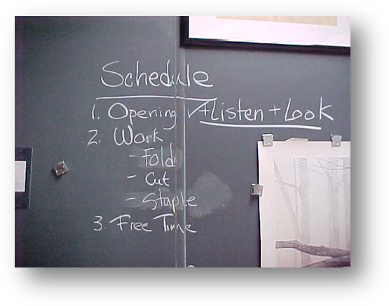

S(A)
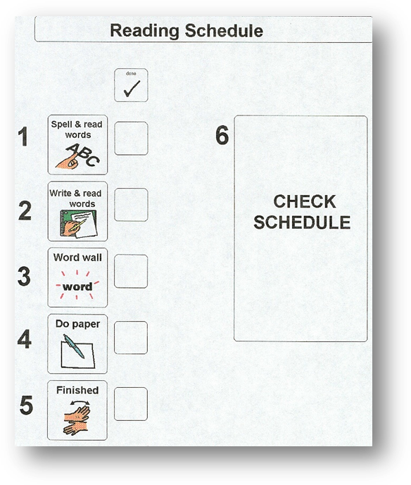
(B)
Mini-schedule (B) was developed by a teacher for a student who has difficulty focusing on tasks during reading class. Having a mini-schedule of the tasks for the lesson helped the student to complete all tasks. This teacher has an excellent website for teams and families supporting students on the Spectrum: www.cindysautisticsupport.com/

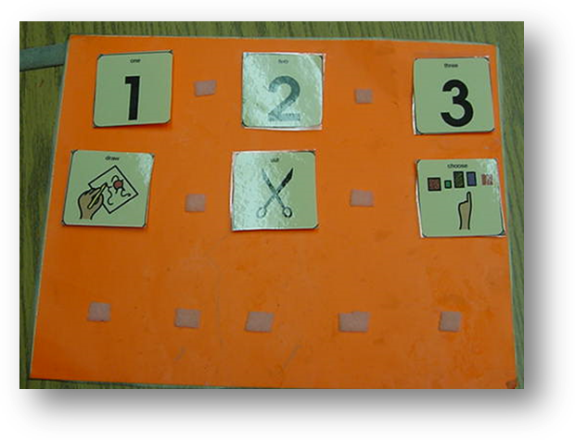

(C)

Mini-schedule (C) is for an art activity. It shows ‘draw, cut, choose’. The student knows to draw then cut then choose an activity from a choice board.

(C)
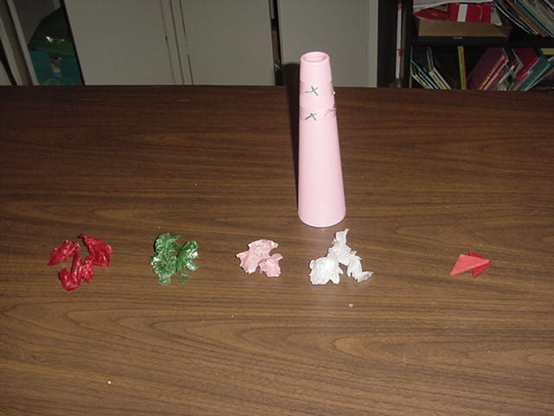

(D)

This visual sequence (D) can serve as a mini-schedule for students who cannot decipher pictures or words for an art class/activity. The “X’s” on the cone denote placement of the colored tissue paper. The paper is placed in a sequence for the student to glue on the cone. When the last paper is placed the student takes the block and goes to the block area to play.

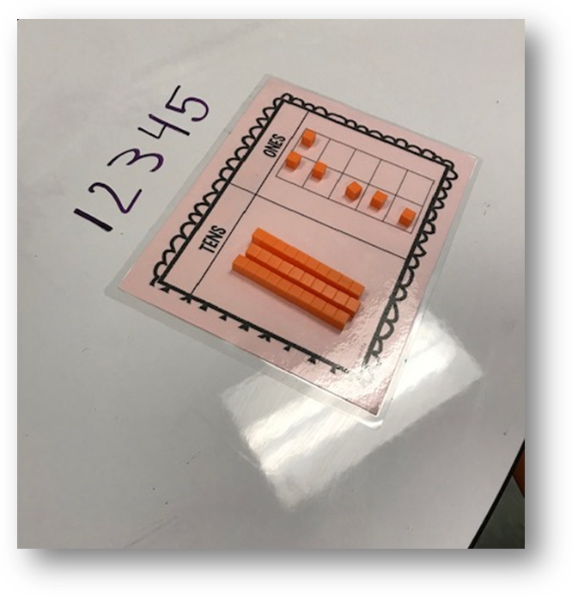
A mini-schedule can be used in – the –moment when a visual support as a mini-schedule was not available. (E)
When the student continually asked: “Are we done? How many more?” during math, the teacher wrote on the desk 1-5. As each problem was completed she erased the numeral. This enable the student to ‘push’ through and decreased the perseverative questioning.

(E)

Mini-schedules can be utilized across a variety of settings including job times. (F)
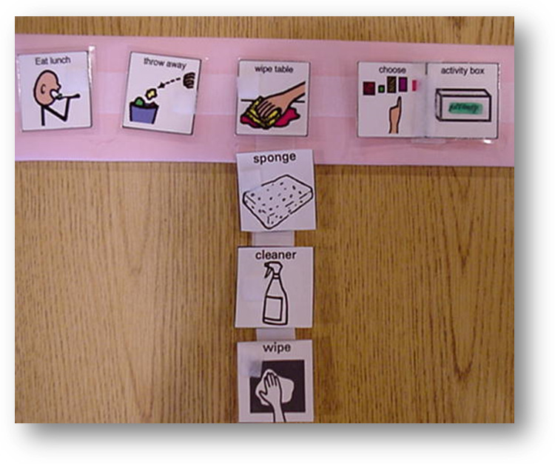

This mini-schedule utilizes pictures and words for students who are non-readers or emerging readers. It includes 2 mini-schedules in one.

(F)
For older students and/or students who are reading proficiently, a simple checklist or written list serves as a mini-schedule. For example, a student in Social Studies Class may have the following:

- Read pages 34-45
- Turn to page 46.
- Take notebook paper and write answers to #1, 2, 3,4, 5, 6.
- Place your paper in the basket on the teacher’s desk
- If the class is still working read your novel
- When the bell rings check your schedule.

Mini-schedules further promote student understanding, independence and success. They can be utilized in special and regular academic settings.

For further information on schedules access the following:
Watson Life Resources: www.thewatsoninstitute.org/watson-life-resources/
www.teacch.com
www.lindahodgdon.com

