Math at School

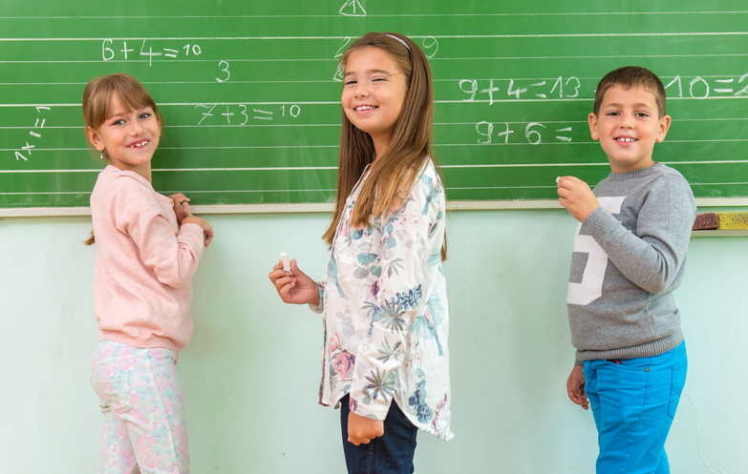
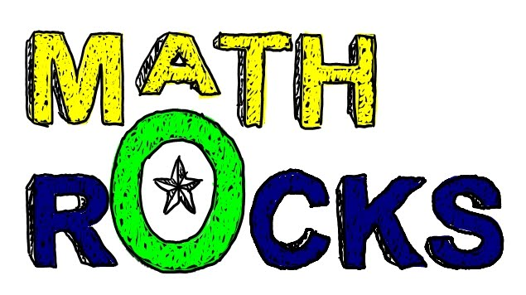

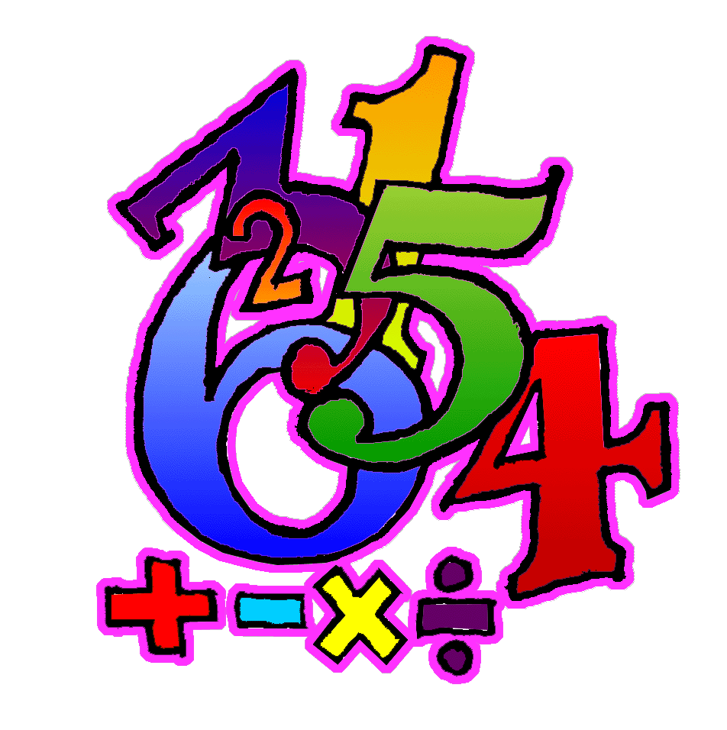
All kids learn math at school. Math is really fun.

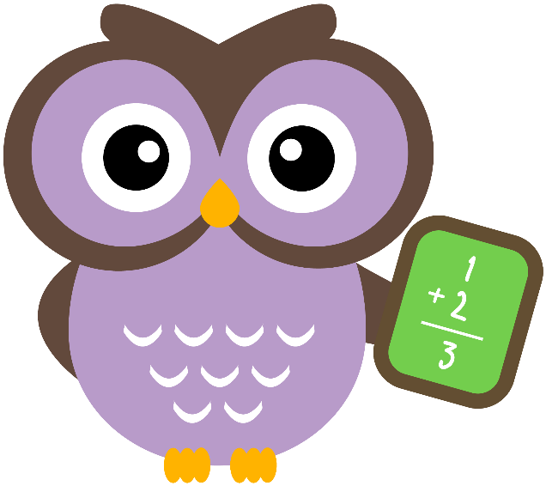
But, sometimes kids have to practice math problems they already know how to do. It may not be fun to have to do math problems and worksheets that you already know how to do.

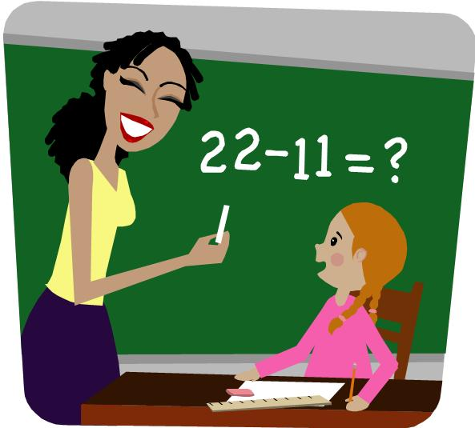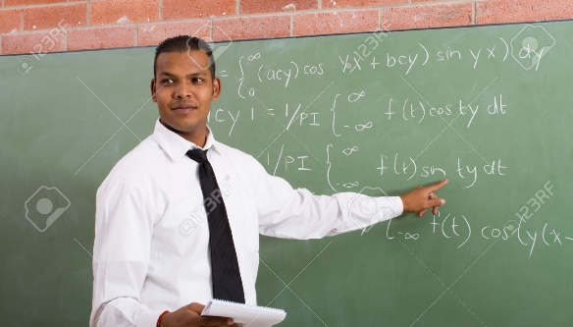

The teachers have all the kids to do the math work. That is their job. They have to give all of the kids the math work even when they know that the kids know how to do the work. All teachers, everywhere have to do it.

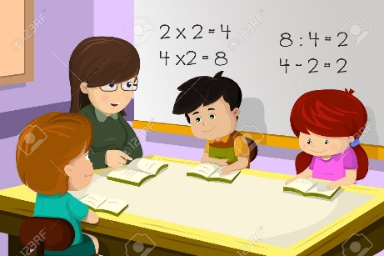

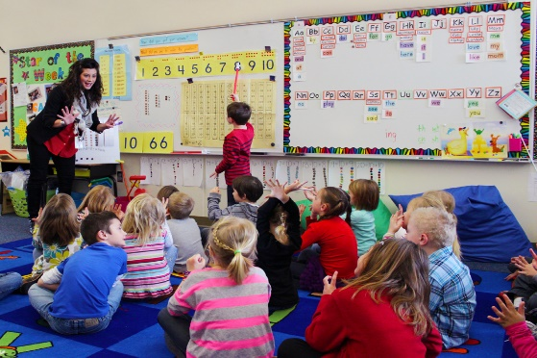
It is the kids’ job to do the work the teachers give them. All kids everywhere have to do it.

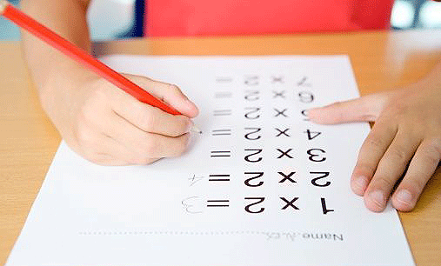
Sometimes you have to do things that are not so much fun to do. Sometimes you have to do math work that you already know how to do.
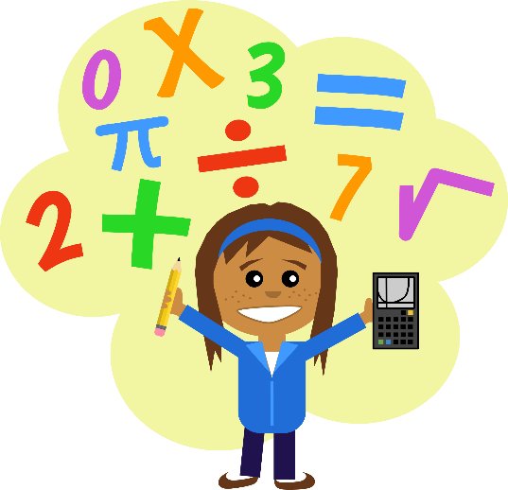

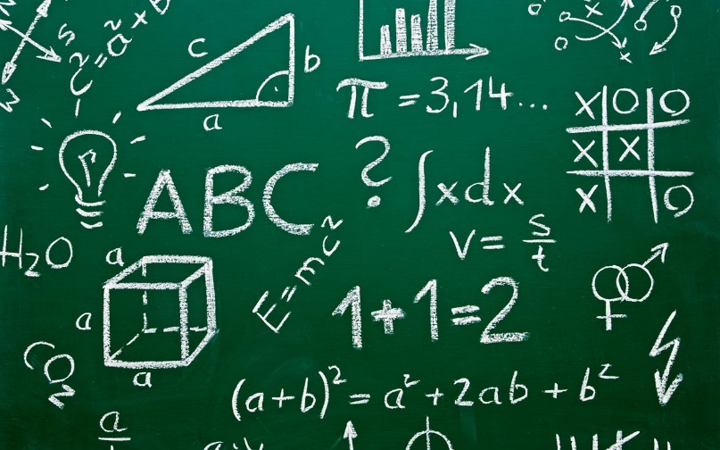

But if you do the work then the teacher will give special math problems just for you to figure out. It is fun to figure out new math problems. First you finish the math work and then the teacher gives you special things to do! That sounds like lots of FUN!!!!!!

The End

