
“LISTENING TO MY BODY”

When I am in school I work very hard.
I am good at raising my hand for questions.


I am good at completing work at my desk or my table.
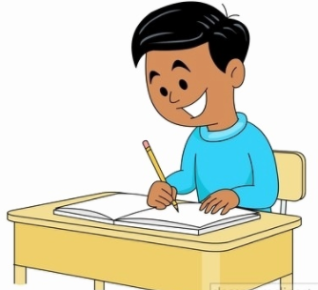

In school kids have to listen to the teacher to know what to do.
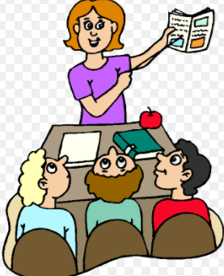

But there is something else kids should listen to – that is their body.

Sometimes your body tells you it has been sitting too long. Sometimes my body tells me this by:

- Wanting to move a lot

Sometimes I can just take a few deep breaths and relax. That can help me get back to work until class is over.
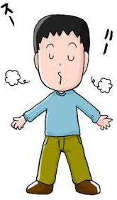

But sometimes my body can be very loud trying to tell me I need to help myself more.

When this happens I can choose to listen to my body and help myself. I can pick between 3 ways to help my body and myself.
  - I can look at the reminder card in my desk and say “I need to go to the bean bag.” OR, “I need to see ________.”
  - I can say, “I need to take a break.” My teacher will give me a break choice.
  - I can tell my teacher I need to pick exercises to do. She has visuals to show me what to do.
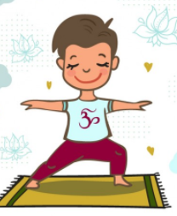

Sometimes I might not hear my body BUT my teacher can hear it for me. When that happens she can help me to know my body needs some help. She can give me a secret signal, like touching her forehead. When I see that signal I can leave and go to the bean bag or she will call _________.

All people try hard to listen to their bodies. It helps them to know when to leave a situation. Between me and my teacher I can learn to “hear” my body.

