
Leaving the Classroom

Sometimes students leave the classroom to go to another room in the building. Some kids leave the class to go to the nurse’s office or the guidance counselor’s office. Some kids leave the classroom to work with another teacher.

Some kids leave the classroom to go to Speech class.

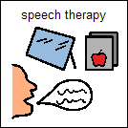

Speech class helps kids learn to talk and interact with their teachers and friends.

Sometimes students leave the classroom to go to a social skills class.

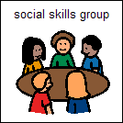

Social skills classes also help kids learn to talk and interact with their friends.

When a student leaves the classroom to work somewhere else in the building, his teacher will show him anything he has missed when he is gone.

When _____ is scheduled to leave the classroom, it will be shown on his daily schedule. He can talk to Mr. _____or
Mrs. ______ if he has questions about his schedule.

______ will try to stay calm and relaxed when he leaves the classroom to work somewhere else. If he feels frustrated, he can:

- Talk it out with an adult
- Take slow, deep breaths to stay calm
- Carry his stress ball or slinky with him

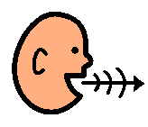

Leaving the Classroom
_____ will know when he is scheduled to leave the classroom to work in another room by looking at his daily schedule. If _____ feels frustrated he can:

talk it out – take deep breaths – carry his stress ball or slinky

