Ignoring Unacceptable Behavior

Sometimes in our classroom, one of the students will do something or say something that is UNACCEPTABLE.
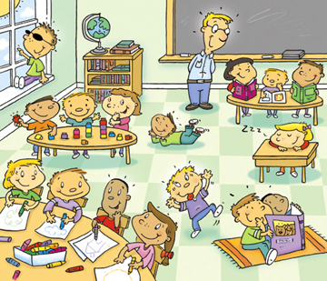

Swearing is UNACCEPTABLE.
Yelling is UNACCEPTABLE.
Calling someone an unkind name is UNACCEPTABLE.
Trying to distract someone from doing their work is UNACCEPTABLE.
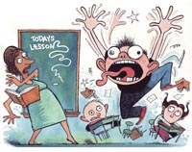UNACCEPTABLE!!!
Sometimes students do these behaviors to get attention. The student wants the other kids and the teachers to look at them and talk back or argue.
WAIT!! If that’s what they want – let’s not give it to them!!!
If the student who is doing the UNACCEPTABLE behavior wants us to argue or yell back – let’s not – We’re better than that!!

We can IGNORE the UNACCEPTABLE behavior!

IGNORE means don’t look at him, don’t talk to him, don’t argue or join in on the behavior.

When you IGNORE the behavior – The UNACCEPTABLE behavior will stop faster!!!
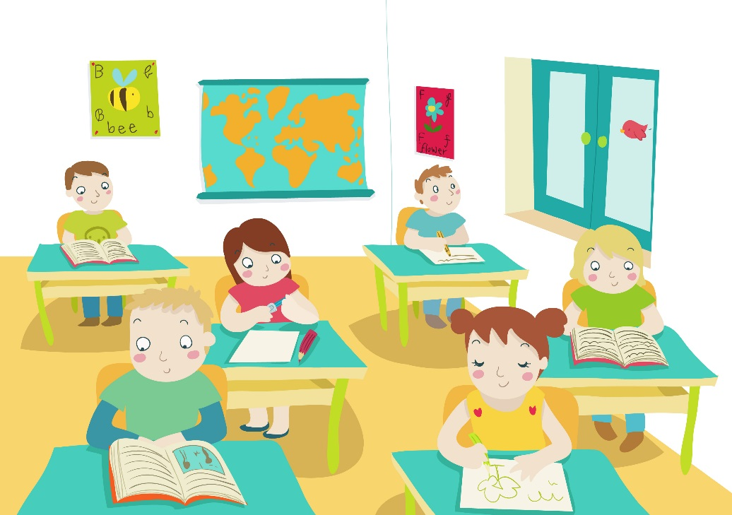

Our Classroom will be much more fun and calm without UNACCEPTABLE Behaviors!!

