I Like

To Draw

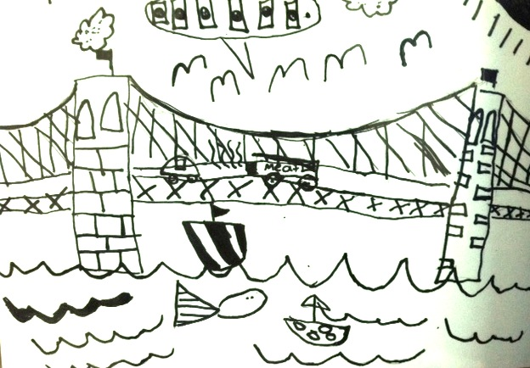

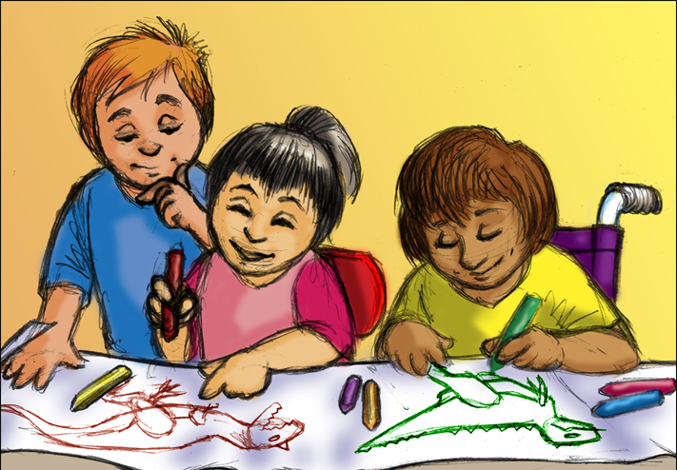

[www.dinosaurparade.com](http://www.dinosaurparade.com)

Drawing is cool.

Lots of kids like to draw!

I like to draw too!

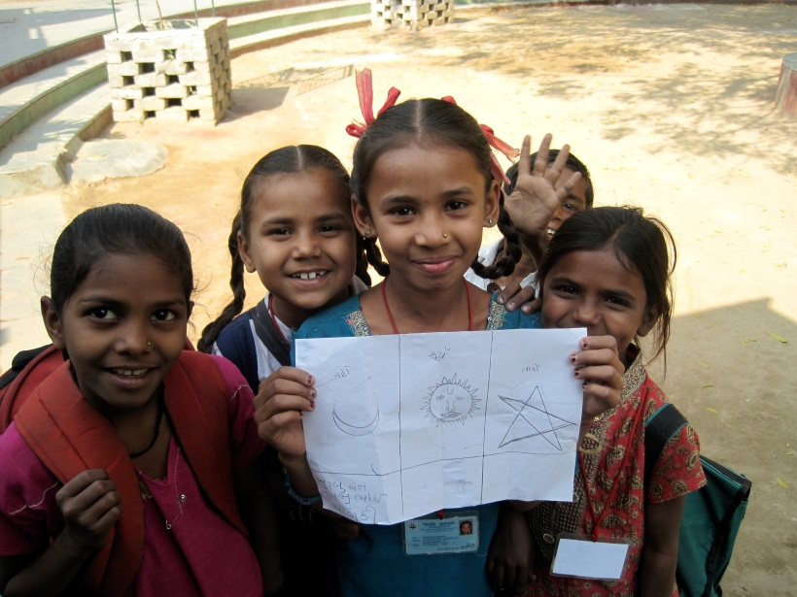

I really like to draw bridges.

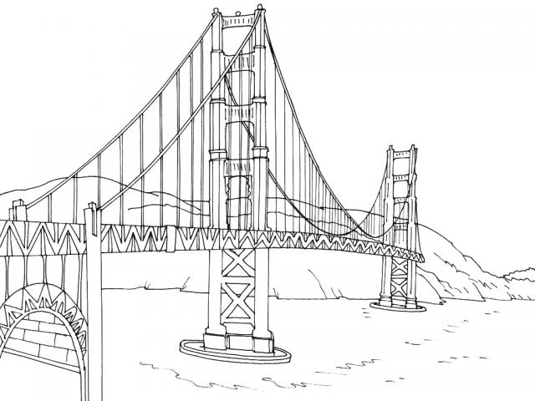

Drawing bridges is fun!

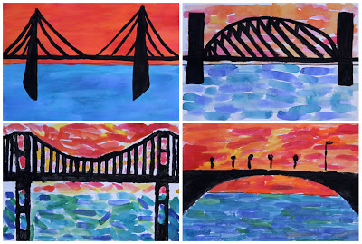

Sometimes I draw other things too.

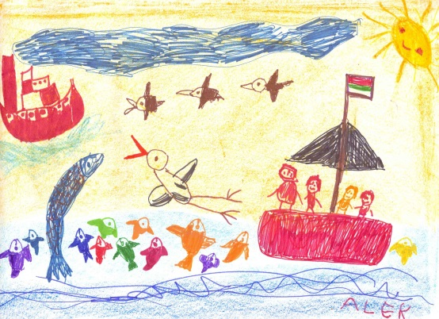

Kids can draw on paper or a black board or a paint easel or even a big board on the wall.

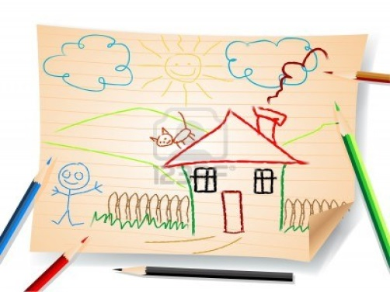 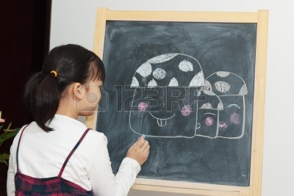

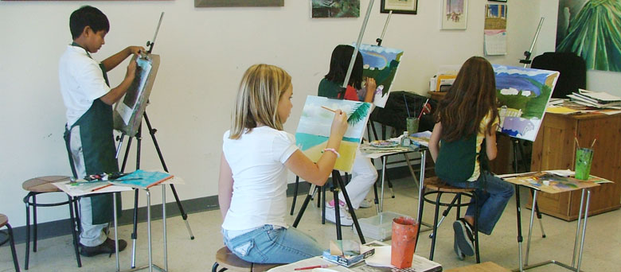

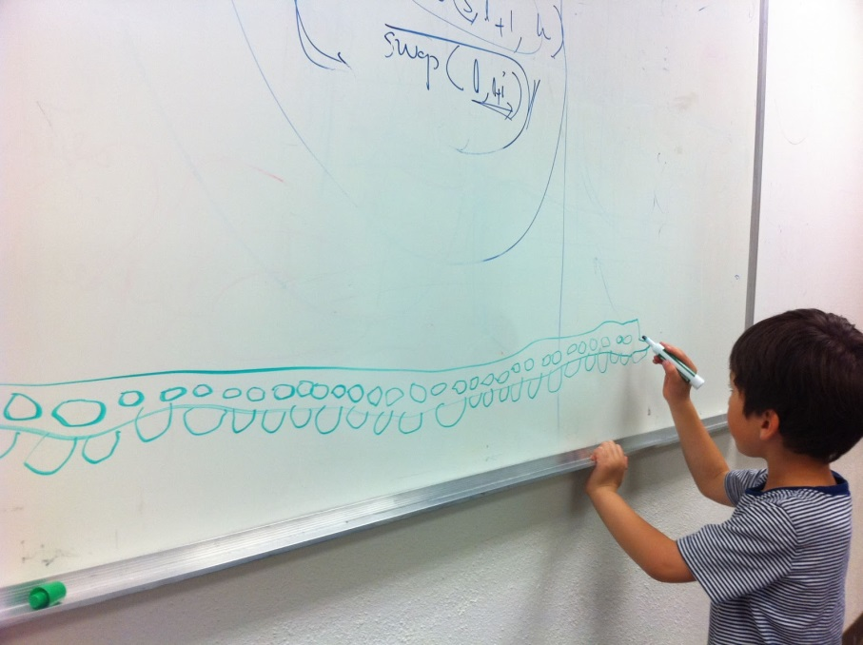

**But kids should try to remember to NEVER draw on walls!**

**It is not good for the wall!**

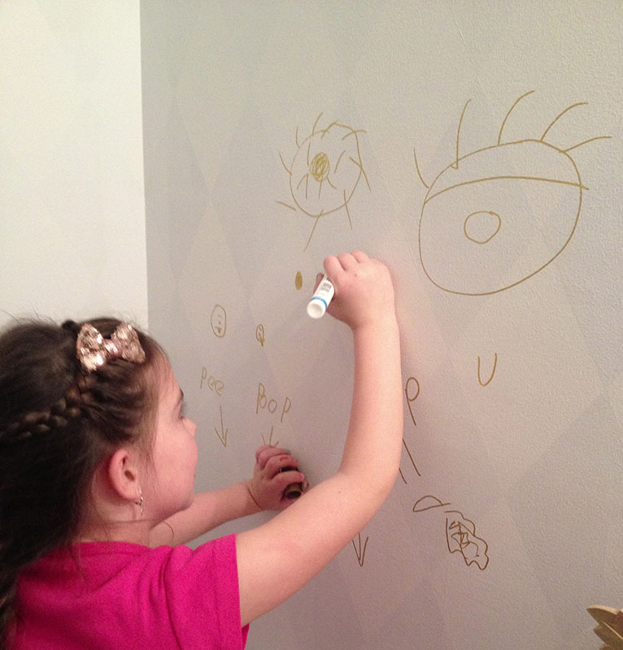



**That is the RULE about drawing!**

**I can draw on all of the other things like paper, a chalk board or a special drawing board.**

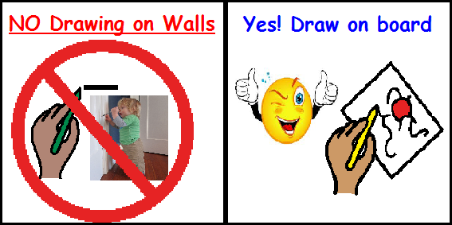

**I can still draw my bridge. I can still draw whatever I want when I draw on my board or on my paper.**

**That’s what kids do.**

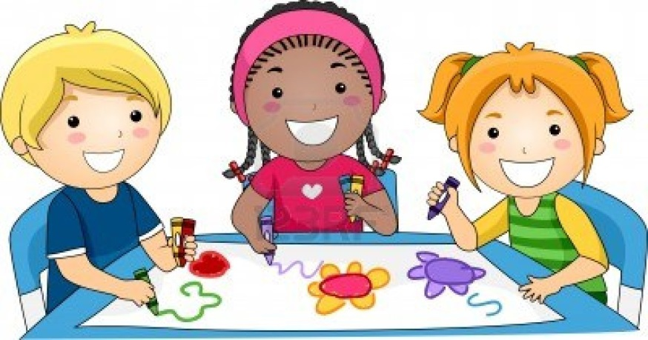

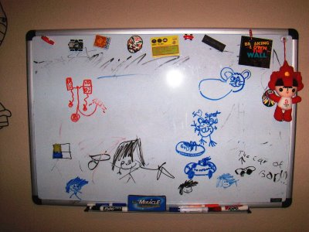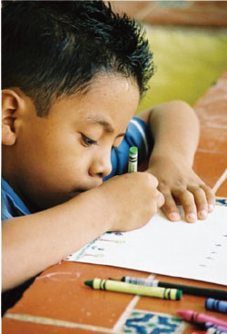

When kids use paper or a special board to draw on everyone is happy!

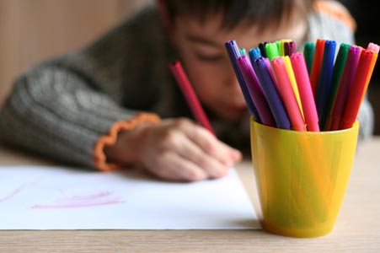

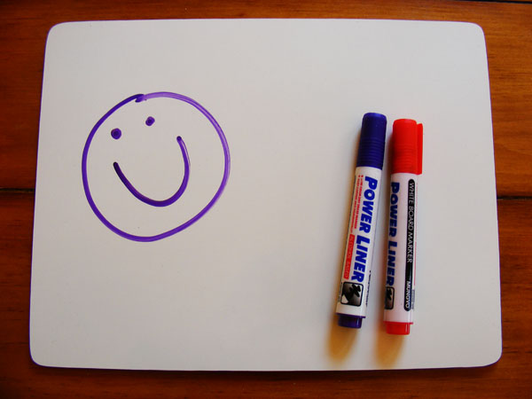

My Mommy will be happy when I draw on my special board.

That will make me happy too!!



The End