How to Talk to My Friends

My name is ____________. I go to _________ Elementary School.

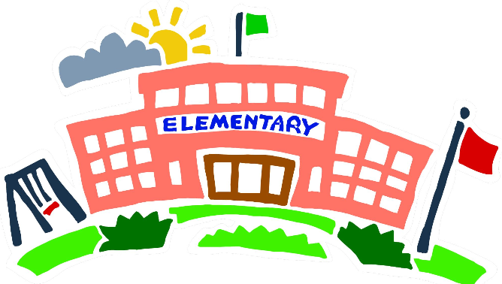

I like the kids in my class. I have friends there too!

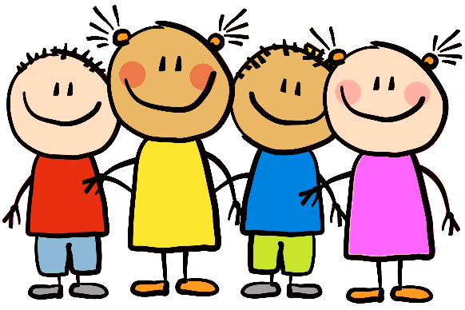

Sometimes I want to show something to my friend. Sometimes I want to say something to my friend.

When I want to get my friend I have to **LOOK at their face and SAY their name.**

Hi Gina!

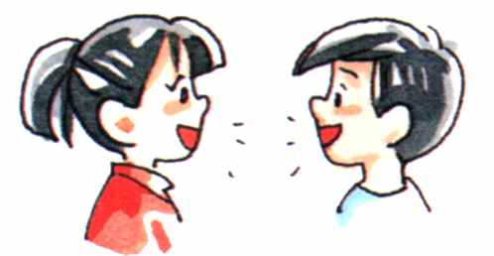

Sometimes I touch their hair. That is not a good way to talk to a friend.

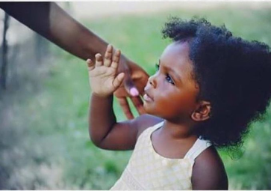

Don’t touch my hair. I don’t like that!

I can tap them on the shoulder but don’t touch their hair.

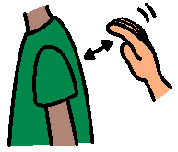

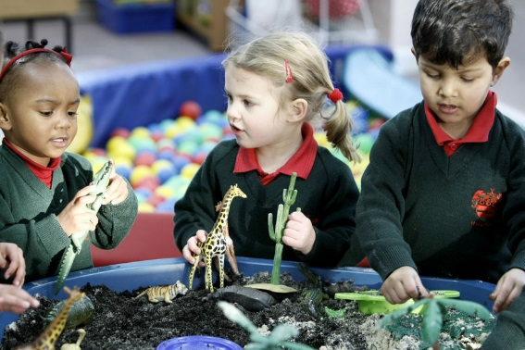

So I will try to remember to

Tap my friend on the shoulder

Say their name

Keep trying

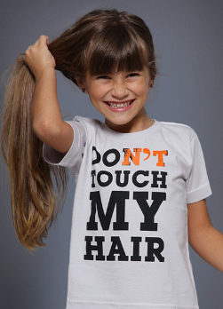

Remember ______

TAP, SAY MY NAME

But don’t touch my

Hair!