
PLAYING KICKBALL

My name is _____ and I go to _____ Elementary School. Sometimes we go outside for recess. I am starting to learn to play kickball outside and at recess.
This can be fun. There are things to
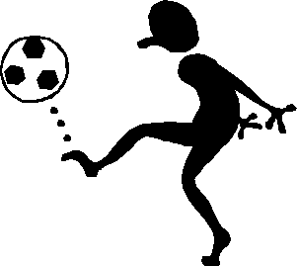
know about playing the game.


The first thing to learn about kickball is that there are two teams. A team is a group of kids who play together. In kickball one team takes turns kicking and running. The other team tries to touch the running kids with the ball.

Next I learn the different positions kids can play. There is a “pitcher” . This is the kid who rolls the ball. There is a “kicker”. He kicks the ball when the “pitcher” rolls it to him.
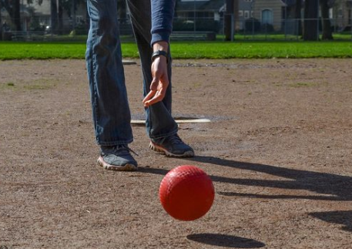

After the “kicker” kicks the ball, he runs to the bases. There is a 1st base, a 2nd base, and a 3rd base.
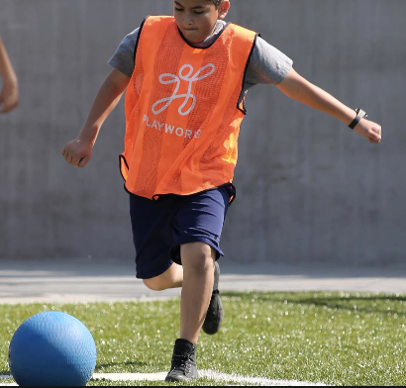
Playworks.org
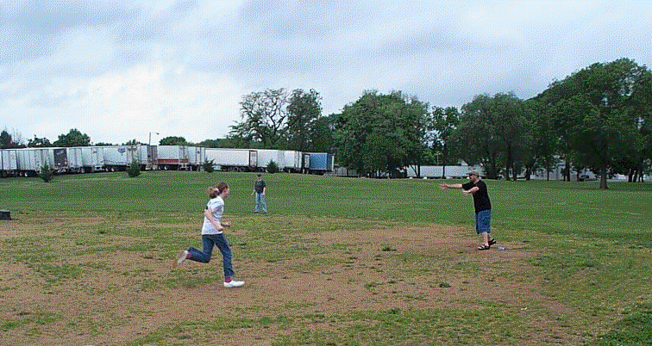
The bases are in a circle. The kicker runs to the bases and then runs back to where he kicked. That is called “Home”.

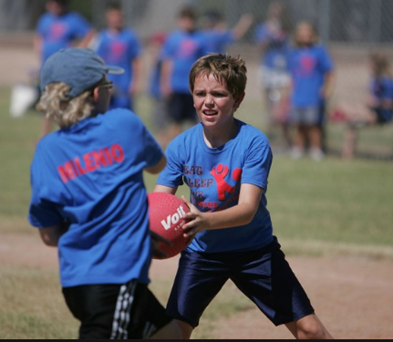
Sometimes the kicker can only run to one base. There are kids on the other team. They will try to touch the kicker with the ball. If the kicker is touched then he is “out”.

Ahwatukee.com

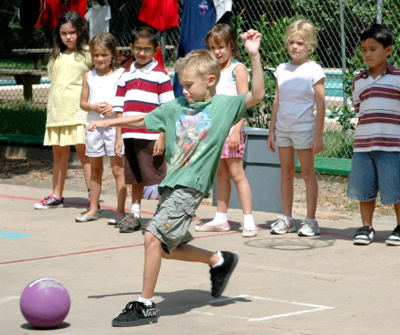
When you are out you go back with your team and wait to see if you kick again. If 3 kickers get touched then the next team gets to take turns kicking.

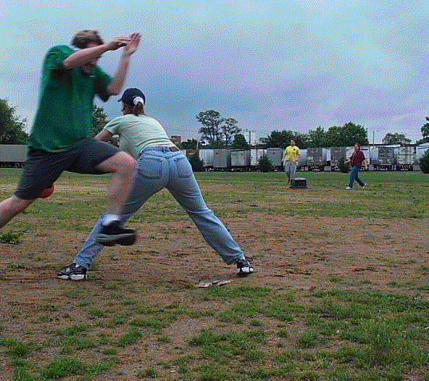
When your team is finished kicking then it is your team’s turn to go into the field. There are positions to play. One person might stand on the first base so if the ball comes to him he can try to touch the kicker from the other team. One person might stand on 2nd and 3rd base and try to do this too.

The “pitcher” is also on this team.

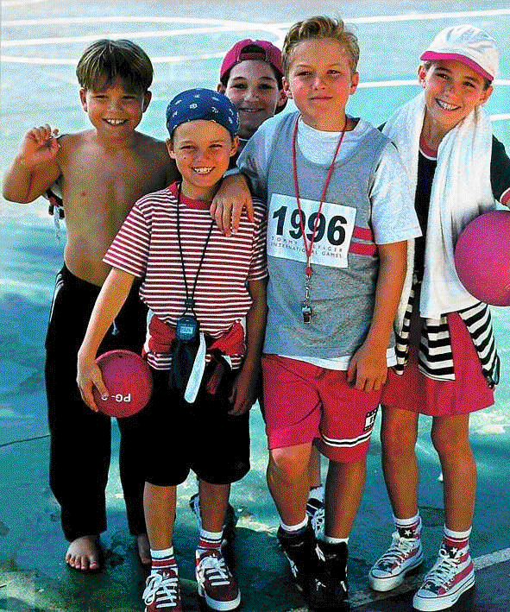

I am going to try to play kickball. Sometimes I might kick, sometimes I might pitch, sometimes I might stand on one of the bases and try to get a kicker “out” by touching him with the ball.

When you play kickball you have to take turns. You have to wait sometimes. When I am waiting I can talk to someone. Playing kickball can be fun.
