How to Keep Princess Hair
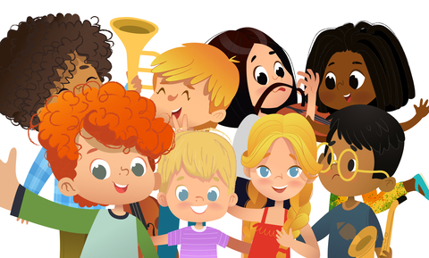
My name is [student name]. I go to [student school]. There are many things I like at school. I like my teachers and my friends.

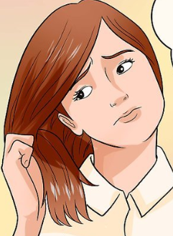
Sometimes when I am learning and working at a table I feel like touching my hair. I like to pull little pieces and play with the pieces.

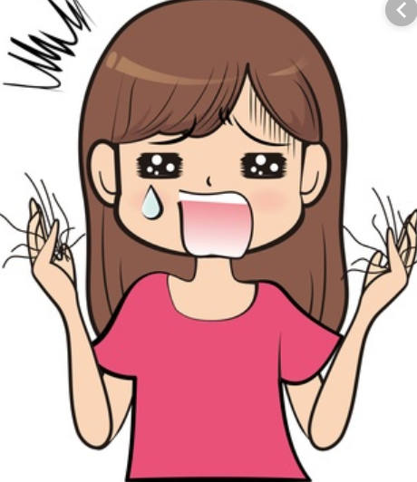
But my Mom and my teacher say this is not good to do. I really like pretty hair and if I pull it I will lose my pretty hair. I don’t want to lose my [insert color of student’s hair] because it makes me look pretty.

There is good news! I can do other things. I can keep my hands away from my hair. My teacher can give me different kinds of string to play with. This feels good like my pieces of hair. My teacher can give me a ‘fidget’ to play with. This feels good in my hands too.
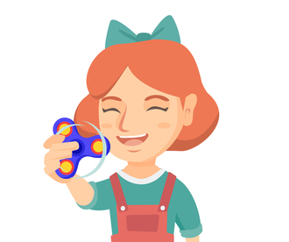
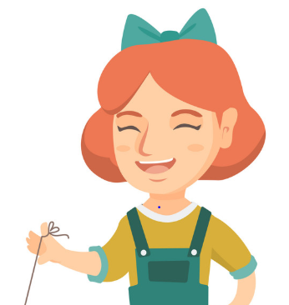

So now I know I can use string or a ‘fidget’. If I try very hard to keep my hands away from my hair at school I can put a stamp or check that I remembered! If my teacher says I remembered to use the string or the ‘fidget’ I can look at a Princess Book.
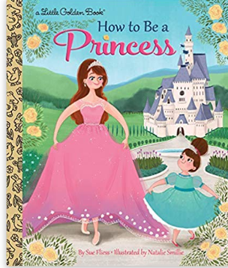

I love stories and pictures about Princesses. Princesses have beautiful hair. They only brush their hair. Most times they try to keep their hands away from their hair. It is a hard thing to do. Here are princesses thinking how to keep their hands away from their hair.
Hmm which one?
Maybe I need a fidget.
What can I do? Maybe use a string?
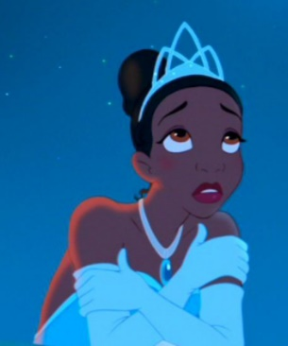
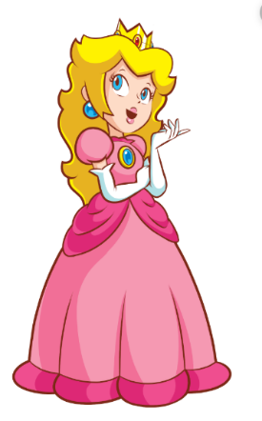
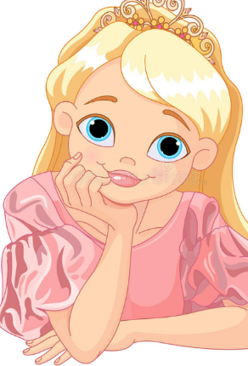

This is a fairy godmother. She is using her wand to give all Princesses a ‘fidget’ or string to use so they can keep their hands away from their hair. (I can just ask my teacher!)
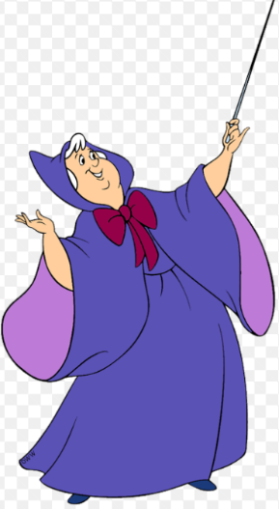
Here comes a fidget and string…Abra Kadabra!

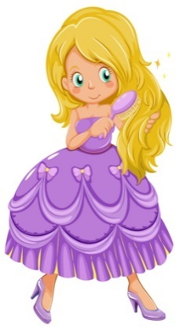
These princesses got the fidget and used it. Now they have nice long hair and can brush it.
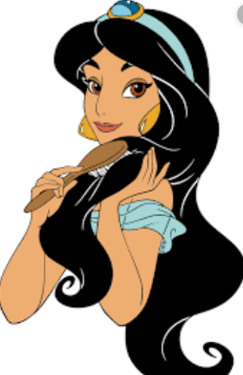

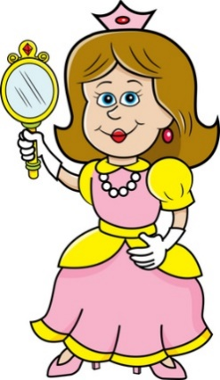
These princesses are happy because they used a string to keep their hands away from their hair. Now they see how beautiful it is!

The Princesses did it! They kept their hands away from their hair! They used a ‘fidget’ or a string. The King and Queen are very proud!
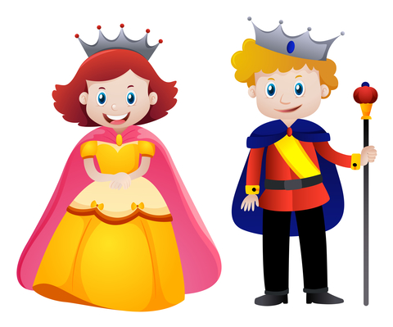
We are so proud of our princess. She kept her hands away from her hair!

Look at all these princesses. They all used string or a ‘fidget’ to keep their hands away from their hair. They are happy and proud because now they have hair and it looks nice. They think I can try too!
You can do it!
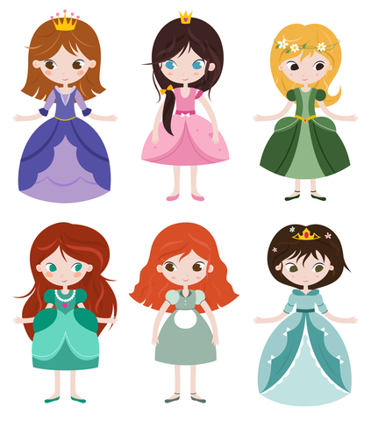

If I try to use string or a ‘fidget’ I will be happy. I can keep track of how I am doing. My teacher and my mom will be proud of me!
