GETTING HELP CAN BE EASY AND GREAT!!
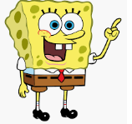
Hi! My name is Spongebob Squarepants. I bet you know me!

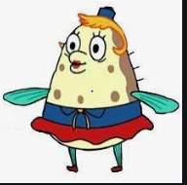
I go to school. Do you? My teacher’s name is Mrs. Puff. I really like her. Do you have a teacher?

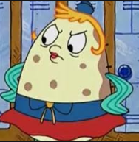
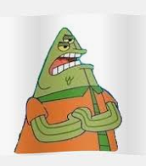
There are times in school when I get upset. Do you? Sometimes another student will do something to upset me. Sometimes the student will tell my teacher something about me. Here is Flats telling Mrs. Puff something.
Spongebob did what?!

Sometimes at school I do good things and Mrs. Puff tells me I do great. She likes to tell me. Sometimes she gives me a ‘high-five’. Does your teacher tell you when you are doing good?
You are doing so well SpongeBob!!
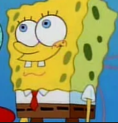

Mrs. Puff might call my name to find out what is wrong. “Spongebob, what is the matter?” I used to think she was mad but not anymore.
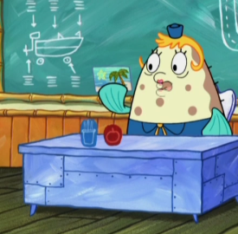

Now I know when Mrs. Puff calls on me she just wants to help me solve the problem.
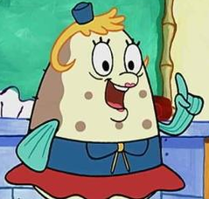
I can help you solve your problem!
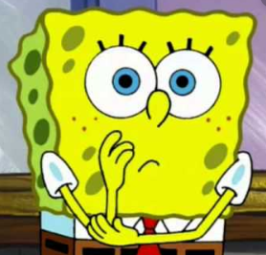

But sometimes when I have to explain something I feel like I can’t. I might feel like I want to yell or run. Sometimes I can’t think what to say.
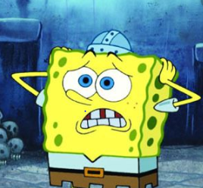
I’m saying the wrong things. I need some help!

I don’t know what to say!!
Umm, you..ahh..I..I mean…

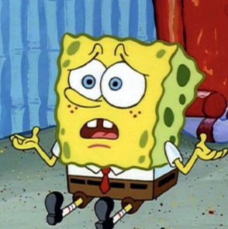
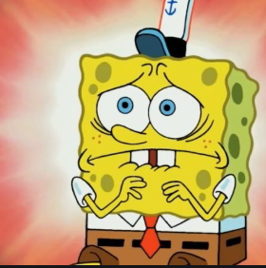

So do you know what I do now I take 3 deep breaths so I can ‘calm’ down.

If I can’t talk quietly I let Mrs. Puff ask me questions. Or, I ask my friend Patrick to tell her. Do you have someone who can help you tell your teacher the problem?
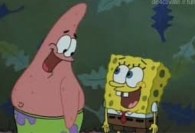
Thank you Patrick!
Don’t worry I’ll tell Mrs. Puff what you mean.

I am so glad I can take breaths, calm down, and let Mrs. Puff help me with my problem. It is good to let adults help! It feels good.
We solved the problem Spongebob!
Thanks! I like it when you help me!
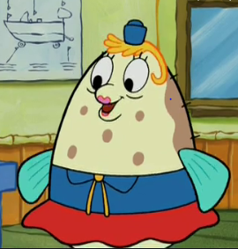

I bet you could try this too! I bet your teacher knows how to help you. It is good to get help. It makes you feel much better!
Take 3 deep breaths.
Your teacher can ask good questions
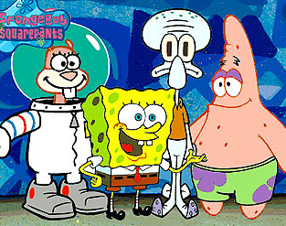
A friend can help!

I’LL TRY IT!!!

