Following the Rules – It Helps EVERYONE

There are many teachers and kids in my school that I like.
They like me too!
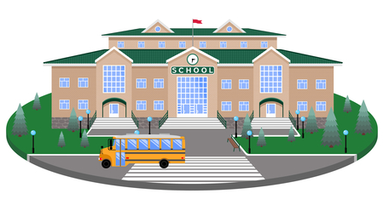

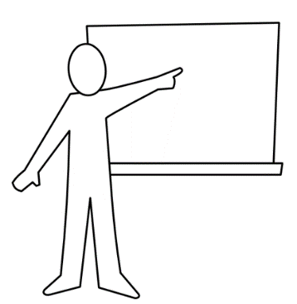
The teachers work hard to teach all the material they have to teach us.

To make it easier we have a rule that we raise our hand quietly to talk. I do that most of the time.

Sometimes I do forget.

When I call out it can confuse my teachers. They might forget what they were just teaching. It is like words bumping into each other and that becomes very confusing.
SSo if we add each number…
This is actually called:
Hey I wanted to tell you….
Interrupting

When I do that – my teacher gets confused and my friends can’t hear or missed what the teacher was saying.
Oh man I can’t catch what my teacher said when kids interrupt
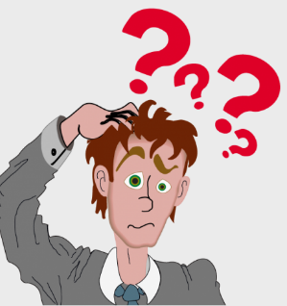
Wait..what was I saying before that interruption?

Just like noise can bother me – this is a noise that bothers my teachers and my friends.

I’m going to try hard to remember to raise my hand and NOT call out loud.

[EDIT WITH YOUR STUDENT’S OWN SPECIAL INTEREST AREA (SIA) ]
A famous person who definitely had to remember NOT to interrupt others is George Lucas.
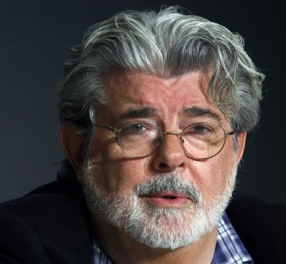
When I was a student in
school I had a hard time but I was very careful and always remembered to NOT interrupt my teachers. I actually taught students too and I never wanted to be interrupted. I tell students to this day they will be successful if they remember to raise their hand to comment or question. It is the best way to learn.
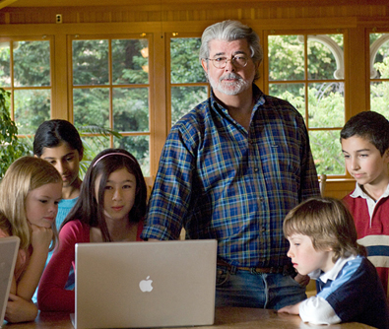
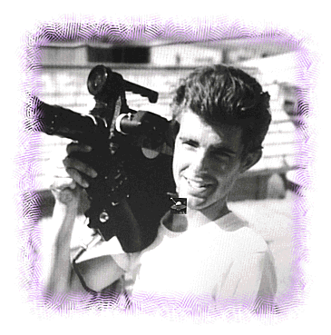
Me as a young film student
Remember Kids – try hard not to call out and interrupt when a teacher is trying to teach – I know because it is hard to teach then!

My career is about working with people so I still remember to listen and not talk when others are talking.

Always try to raise your hand during classes – that helps you, your classmates, and your teacher!

Remember to try and raise your hand when you want to comment or ask a question, or volunteer.
This helps you, your teacher, and your classmates

Yep – raising my hand
and not interrupting
helped make me
Successful!

