
Following the Rules of the Game

Games are fun. Playing sports and games is a great way to make friends and get to know other people.
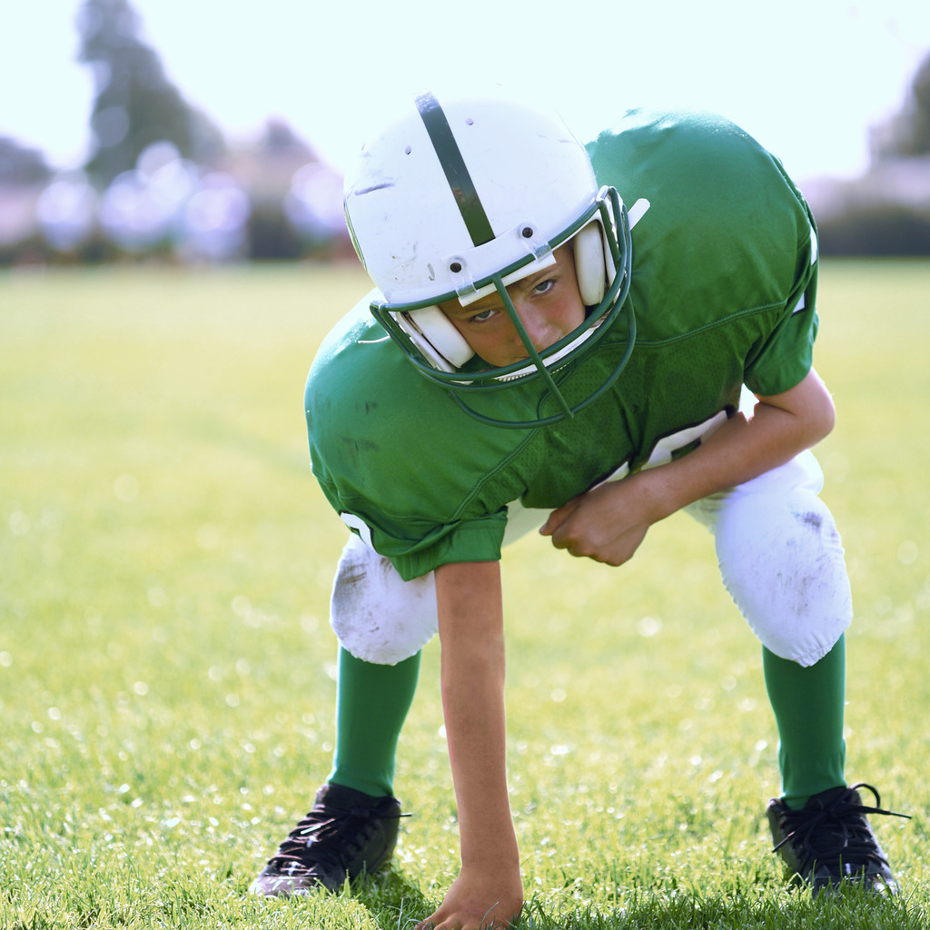

But there are rules in sports. The athletes have to follow these rules, or they will get penalties.
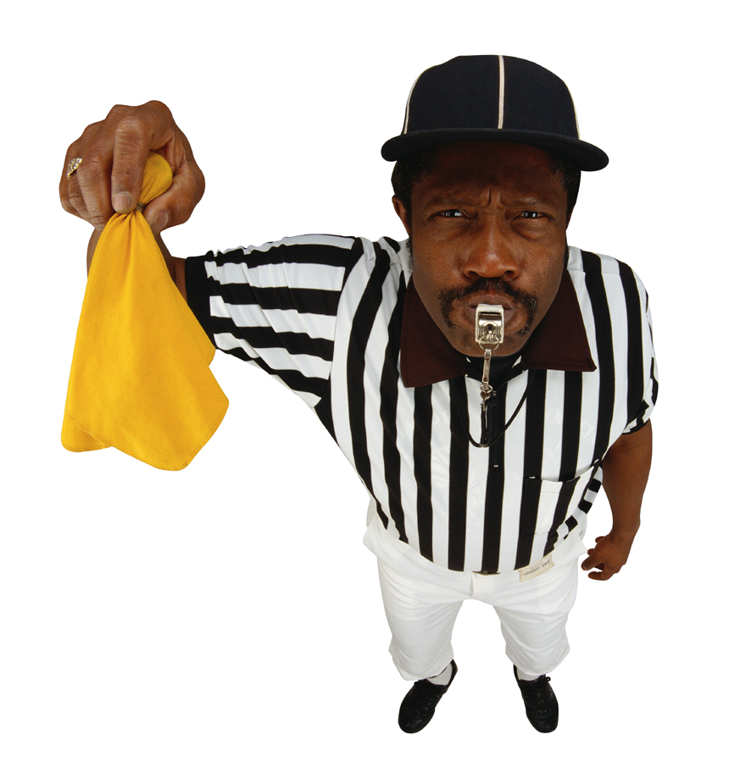

In Football, the person that is carrying the ball is not allowed to step out of bounds. If he steps out of bounds, the play is over.
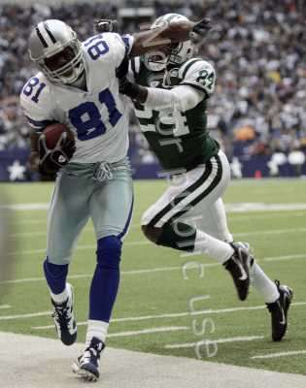
What would happen if Ben Roethisberger refused to end the play? It would not change the score of the game. If Hines Ward would not end the play, he might get penalty yards or the coach might take him out of the game.
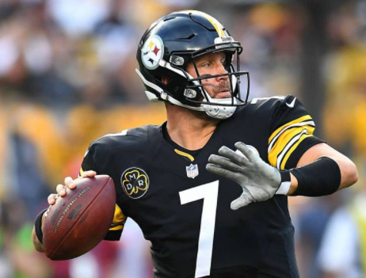

In basketball, you are not allowed to move with the ball in your hand if you are not dribbling. This is called traveling.

When LeBron James makes a mistake and “travels”, the referee will blow the whistle and the other team gets the ball.
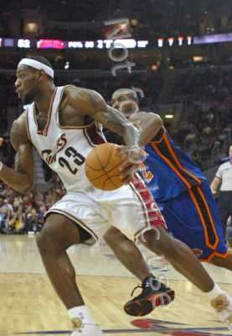
What would happen if LeBron James refused to give the ball to the other team? It won’t change the score of the game. LeBron may be removed from the game.

Some players are even given personal foul calls or fines when they don’t follow the rules.


When kids are playing sports in gym class or at recess, they are practicing to be good athletes. To be a good athlete, you have to be a good sport. You have to follow the rules.
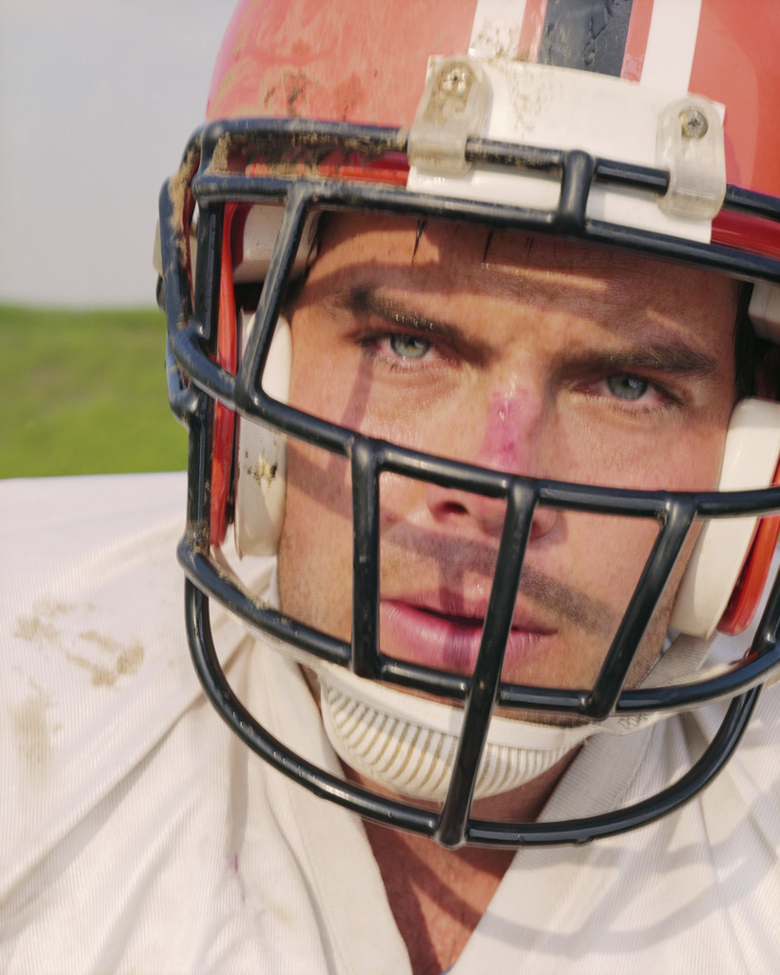
Here are some important ways to show you are a good sport:
- Be polite
- Don't show off. Just play your best.
- Tell your opponents "good game!" whether you've won or you've lost.
- Learn the rules of the game and follow them.
- Listen to your coaches and teachers and follow their directions about playing.
- Play fair and don't cheat.
- Cheer for your teammates.
So, now you know how to be a good sport! Get out there and practice!!!

