
The Fidget Rules

A fidget? What’s a fidget?

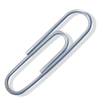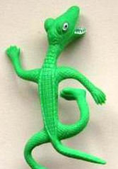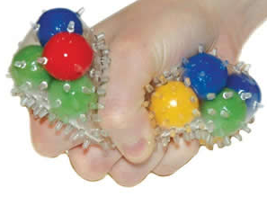
A fidget is a small object that keeps your hands busy, so you can pay attention to the teacher.
Sometimes a fidget can help you listen better during class.

A paper clip, eraser or small toy can be a fidget. You can hold it in your hand and feel it, move it and play with it while you’re looking at the teacher.

A fidget feels good in your hands and it keeps your hands out of trouble.

How do I know if I need a fidget?

It’s good to use a fidget when you are having trouble paying attention in class.
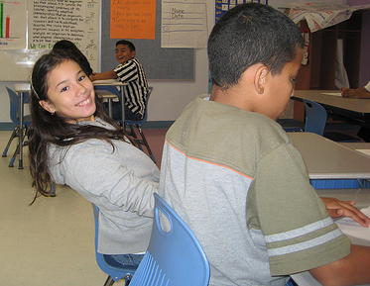
It’s good to use a fidget when you keep touching things you’re not supposed to touch.
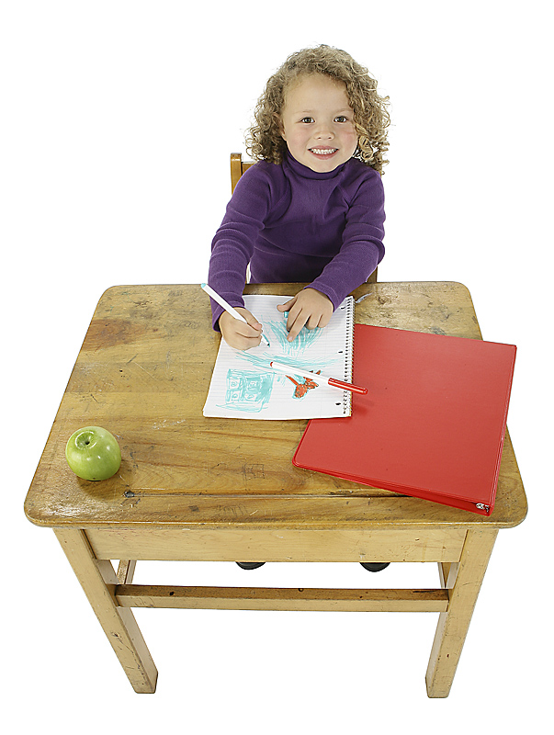

There are some important rules about using a fidget, though.
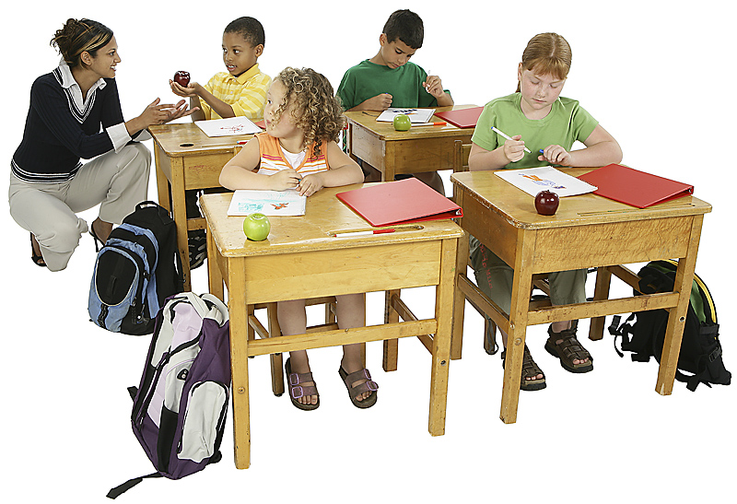
One rule is that you shouldn’t need to look at the fidget very much. If you look at the fidget too much, then you won’t be paying attention in class.

Another rule is that you shouldn’t try to get your friends attention with the fidget. It’s not fair to disrupt other people that are trying to learn.

Another rule is that the fidget needs to stay in your hands or on your desk. A fidget is not to be thrown or dropped or bounced.

So, a fidget is a good thing to use when I’m having a hard time paying attention. But, I have to be careful to follow the Fidget Rules.


