What To Do When I’m Sad or Mad (especially when I’m Mad/Angry)
My name is [student name] , and this is a story about me! I go to [School Name]. I know many kids and adults at [School Name]. Some of my friends are [ insert student names]. Some of the adults I know are [list adult names].
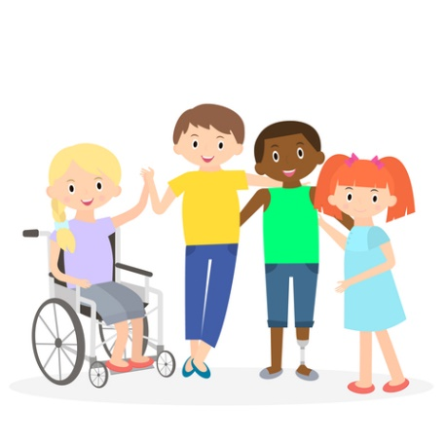

All my friends and teachers and other adults at [School Name] are like me. They have feelings. Sometimes I feel happy. Sometimes I feel sad. And sometimes I even feel angry or mad. Guess what? My friends and teachers, and lots of other people at [School Name] feel like I do too.
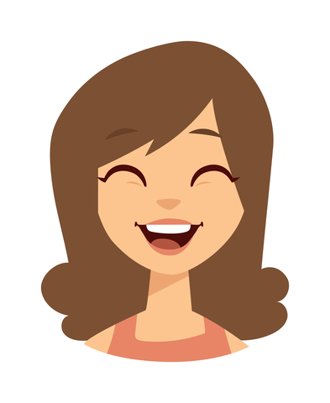
This is what feeling happy looks like!

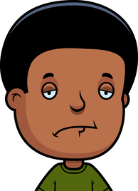
This is what feeling sad looks like.

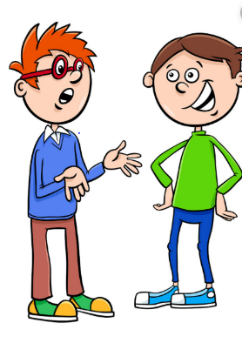
Usually when we feel happy we smile and talk to each other. When we feel sad we might cry or put our head down, or go to another place where it is quiet. We might want to talk to someone too.
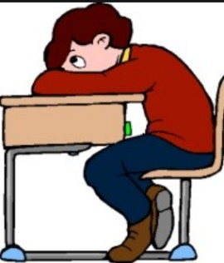

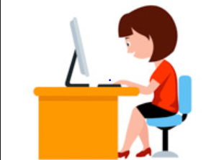

But when we feel angry it is hard to know what to do. Sometimes I feel like hitting or pushing. Sometimes my friends feel that way too. But guess what? My friends, teachers, and other adults at Harrison try to do some other things when they are mad.

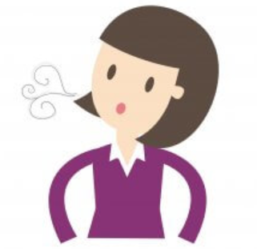
This is taking a deep breath. Breath in and out 3 times when angry.

Kids and adults might squeeze their hands together when they are angry.

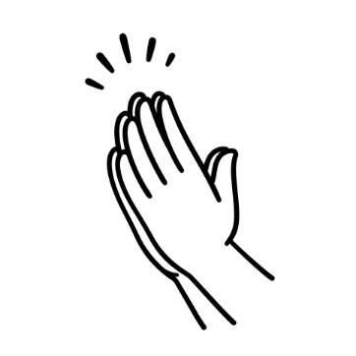
This is squeezing hands when you are angry.

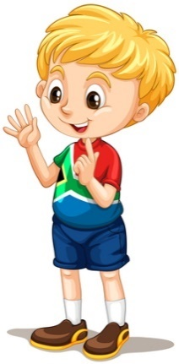
My friends might count to 10 when they are mad.
This is counting to 10 when
feeling angry or mad.

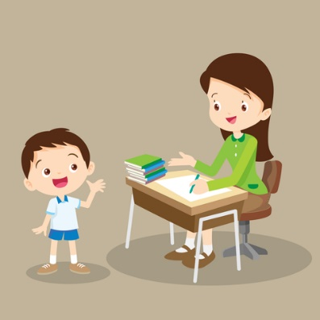
They probably go tell an adult how they feel because the adult can help them.

When my friends and teachers and other adults think of something else to do when they are angry they feel good about themselves. They know they made good choices. Sometimes they might write a note home to their mom about the good choice they made. They might write:
Dear Mom,
Today I got angry. I took 3 deep breaths then stopped and told an adult why I was mad. After I talked I felt better.
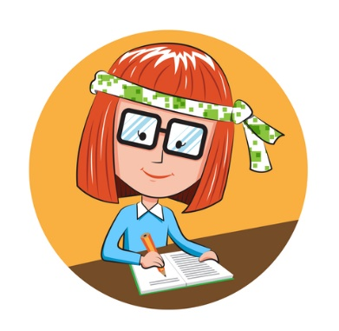

When I make good choices, I use a chart to show my Mom.
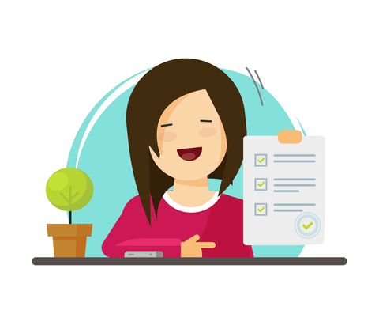

This is what I’m going to try and do too. When I get mad I will try to take 3 breaths, or squeeze my hands, or count to 10 and then talk to an adult.

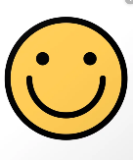
I will feel better because I made good choices. When I make good choices I get happy faces on my chart!

That makes ME happy too. When I make good choices, my mom will be proud, my friends will be proud, my teachers will be proud and so will I!

