
Eye Contact or Staring
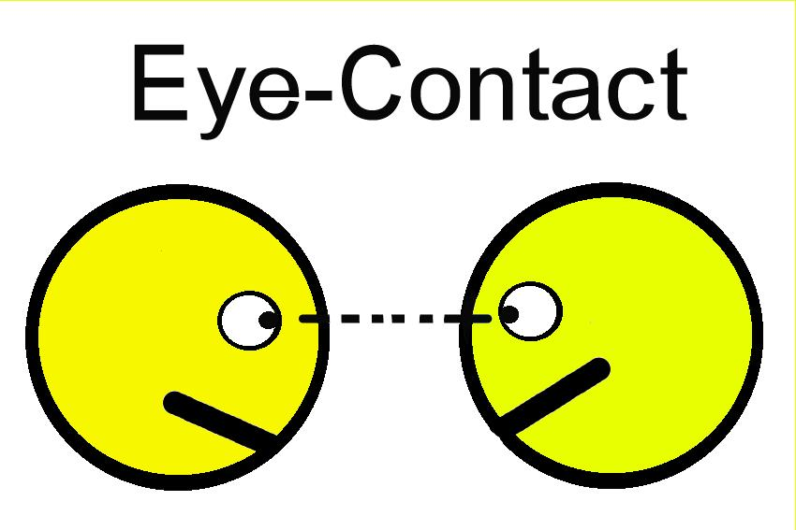
Eye Contact

Or
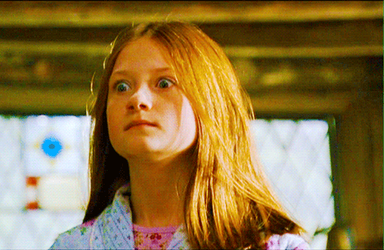
Staring



When we talk to friends or other people it is best to look them in the eyes.
Eyes show how a person feels without saying a word.
Staring is different. Looking at someone for a long time without looking away or talking

is called staring.
Staring can make friends and other people feel uncomfortable.
I will try to remember to have good eye contact when talking to friends or other people. I will look my friend in the eyes for a couple of seconds, look away for a short time and then back at my friend.

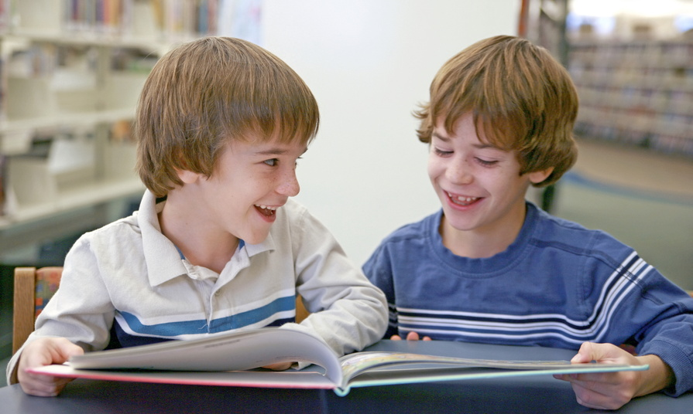

I will try to have good eye contact and not stare when I am talking to my friends or other people.

