EXPECTED BEHAVIORS FOR DRAWING
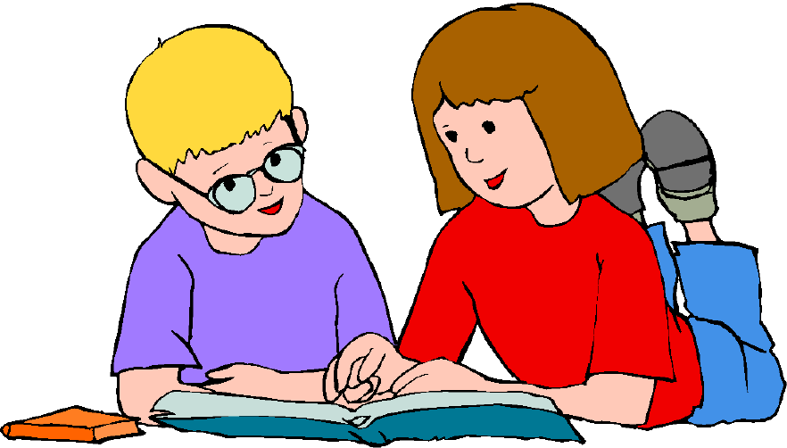
I love to draw – and I’m really good at it. When I draw well and when I draw things we are asked to draw (like in art class) that is called EXPECTED Behavior. When a person does things that are EXPECTED then adults and kids want to be with that person. They want to hang out with them, talk with them, want to be their friend. When you do EXPECTED BEHAVIORS you make people feel calm and good.
Wow [student name] drew stuff for class that the teacher asked him too – looks so good! Maybe he can show me

Sometimes when I draw I feel like drawing things that are UNEXPECTED. Sometimes I do that when I’m angry at someone and it can be hard to stop.
But…drawing things that have hurtful illustrations about people or language people don’t usually use can make people feel shocked and surprised and uncomfortable. It can make people not want to be around the person who draws like this.
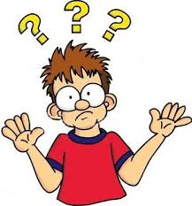
Why is he drawing like that – so uncool

If I draw these things in school I could really make that person feel bad. That person might be disappointed in me.
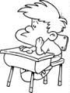

When I feel angry about something and feel like drawing things that might makes someone feel uncomfortable, I can do other things. Two good ideas are:
- If I’m angry about something I just ask to talk to an adult who can help me out. I could ask to talk to [adult name]. I could ask to talk to [adult names]. I could ask to talk to [adult name].
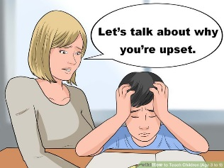

- When I’m with an adult talking, I could ask to draw how I’m feeling. I would just draw in a private notebook in their office.

These 2 things would be EXPECTED BEHAVIORS.
I can try think of other EXPECTED BEHAVIORS
When I’m angry like:
______________________________
I’m going to try hard to:
Express my anger in EXPECTED WAYS

When I feel angry and want to draw things that are UNEXPECTED – I’ll STOP and try to:
- Ask to talk to another adult
- Ask to draw my feelings in the adult’s office
OR: ___________________________
___________________________
THESE THINGS ARE EXPECTED BEHAVIORS
Expected Behaviors make kids and adults like you. Good things happen when you do EXPECTED BEHAVIORS

