
Everyone Asks Questions!
Can you help me?
How do I do this problem?

Can I get a drink of water?

Is this correct?

Questions, questions, questions. There are always so many questions. We all ask questions. That is how we learn new things.

Asking questions helps us understand new information and people.

Sometimes we need to ask questions to get permission from someone or check that we are correct.

At school, when we ask a question, we are supposed to raise our hand and wait for the teacher to call on us.



Teachers really like to help kids at school. Teachers like it when students ask questions.

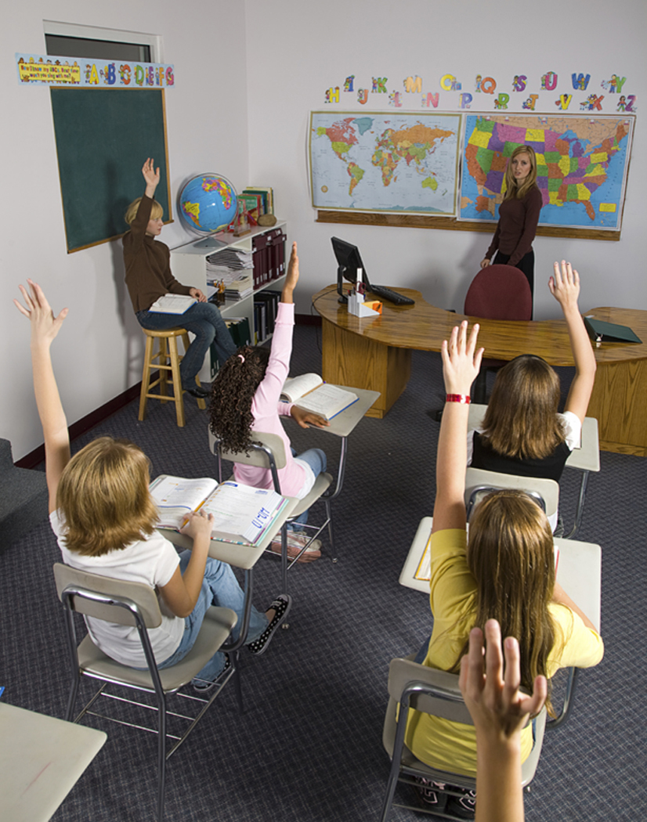

Asking questions shows the teacher that you are interested and paying attention.

You can ask a teacher a question about your school work.
Or, you can ask a teacher for permission to go to the restroom or get a drink of water.

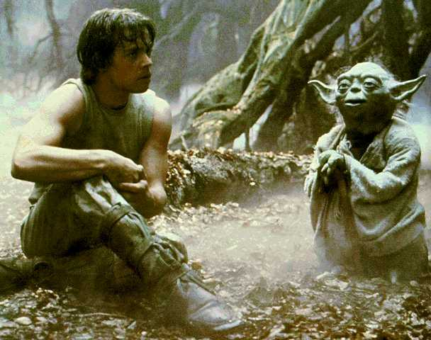

Luke asked Yoda many questions. That is how he became a great Jedi.

So, it’s a good thing to ask questions.
- Ask questions to show you are interested.
- Ask questions to learn new things.
- Ask permission when you want a drink of water or need to use the restroom.

It is great to ask questions at school.
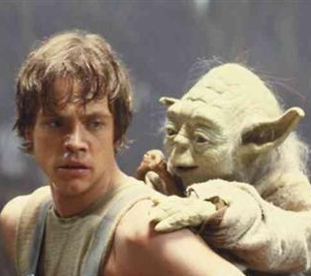
Remember:

Asking questions will help you use the FORCE.

