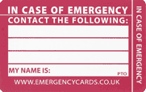
Ms. ____ or Mr. ____
They will help me make a plan in Ms. ____’sroom
Ms. ____ or Mr. _____

