Johnny’s Family Story


Each child has 2 parents.

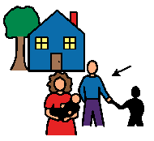
Some children have parents who are married. These
parents live in the same house.

Some children have parents who are divorced. These parents live in different houses. This is ok!

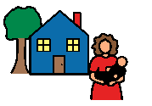
Mom lives in one house.
This is ok!


Dad lives in another house.
This is ok!


Parents who are divorced love their children very much!


Mom loves me a lot!


Dad loves me a lot!

