Wow, All My Friends Look Different But We are also the Same!!
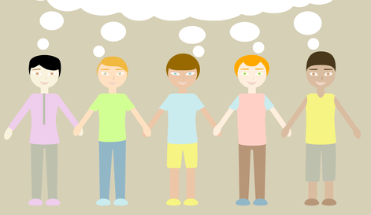
Humans come in all sizes, colors, and differences. It is interesting that although there can be MANY differences, we end up being the SAME too.
Differences – here are a few:
- Skin Color
- Size
- Weight
- Religion
- Ethnicity (share common language, culture, and other things)
- Talents
- Skills
- Ways we learn
- What we like
- Hair and eye coloring
- Language
- Type of houses we live in

Can you think of more?

But – we are SO much ALIKE even when we look DIFFERENT:
- Everyone has feelings – of sad, happy, excited
- We all can get hurt physically or with our emotions
- We all like to have friends
- We all have certain things we like to have or play with
- We all have the same internal organs
- We all have the same physical things that make us human
- None of us really want to hurt anyone
- We all have some kind of family or relatives
- We all have someone we especially like to talk to
- We all have ways to get to places – like car, walk, plane, train
- If we are kids we all go to school somewhere ( in this country)
- We all wake, sleep, and dress

Can you list more?

There are many websites that explain our differences and yet also explicitly state that we are also alike.
http://genetics.thetech.org/about-genetics/why-we-are-different Did you know that if we compare our DNA 99% is the same!!!

The most important SAME thing to know is:
We all have feelings. So if someone says something mean about being different to another person. That will definitely make them feel bad. No one really wants to do that. If a person is saying mean things just because someone is different it probably means they just don’t understand and should try to find out what things they both have in common.
If you are one of those people who is confused about differences and say things to hurt people try to:

- Talk to an adult about questions you have regarding other people.
- If you are thinking something, keep it in your head – not out the mouth, until you can talk to someone
- Learn about differences – don’t be confused

Remember, saying mean things just because someone is different can turn a person into a Bully, and no one wants to be called that!

