Did my Pet Get Lost or ….. ??

My pet’s name is ________. ________ is a member of our family!

Insert pet picture here

We got _______ when [he, she] was ______.
It is possible [he, she] ran to see some of [her, his] own friends that we might not know about.
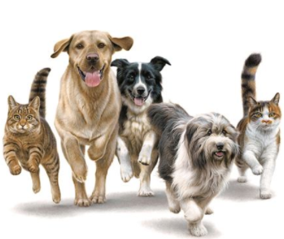

We think [ he, she] was able to go on [his,her] own because:

If [he, she] decides to come back we will try to:

My family is going to do everything we can to see if we can find where _______________ went.

Some of the things we are going to try are:

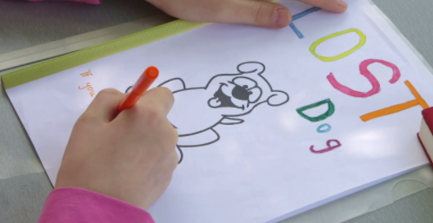

If I make a poster, mine will say: “Have you seen…” because I think ______ knows right where [he, she] is!

