Connecting with People
This year I’m in a new school building. I came here along with all the other ______ graders and am now in ____grade!!
Insert picture of student’s School Building

I have friends in this building. I have fun talking with them at lunch.
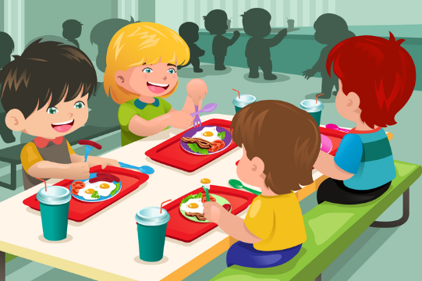

When we talk at lunch we look at each other and share information. We take turns in our conversations. I like it when my friends listen to me and they like it when I listen to them.
Sometimes in class we get to talk with our classmates too. When we do that we look at each other again and share information according to the teacher’s directions.

But sometimes in my class I might put my head down when a classmate starts to look at me and talk to me. I sometimes do this because ____________.

But that really makes my classmate feel bad. He or she isn’t sure what to think. If someone I talked to turned away or put their head down. I would feel bad.
What did I do to him? Why won’t he talk with me?

I’m going to try and look at my partner in class and share my thoughts. I’m very creative and pretty smart. I can help my classmate. I can also listen to him or her. That would make them feel good because other people have good ideas too and they like people to listen to them.
(Edit with student’s own special interest area SIA)
Someone I think is great definitely knew how to listen to people. That is why he has tons of friends AND how he became successful.
That would be George Lucas.
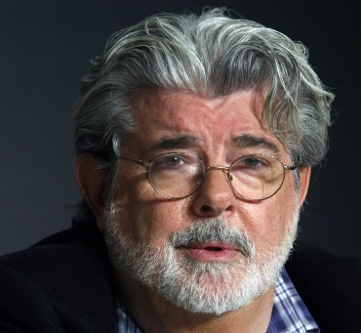
When I was in school I had a hard time with the work. But one thing I did not have a hard time with was listening and talking to people. That is why I ended up with so many friends even today! I’m pretty good with my social skills. I know to:
Look at a person when they talk to me
Wait till they finish
Nod my head or say things like “mmhmm”
Then share my thoughts with them

My career is about working with people so I still remember to listen when others are talking, make eye contact, and respond to their thoughts. Then I share my ideas too. That is why I was successful with Star Wars – I had my ideas and I listened to others too.

I NEVER ignored or said mean things to any of my classmates, my friends, or my teachers. I know they always wanted the best for me.
I did have one trick though, if I was frustrated about something as a kid I just quietly told the teacher or another adult instead of reacting out loud. That helped me AND kept me good with friends and with my teachers!

You can have those tricks too. First, remember to:
- Try eye contact with classmates
- Listen to them
- Then share your ideas too
- If frustrated with anything just quietly tell an adult – they usually come through with a plan to help
I actually work with kids now too. I teach them about movies AND how to be social with their friends and adult. It can get you a long way in life !!!
