**PLAYTIME and CLEAN-UP**

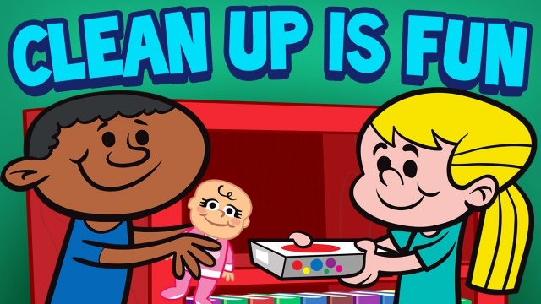

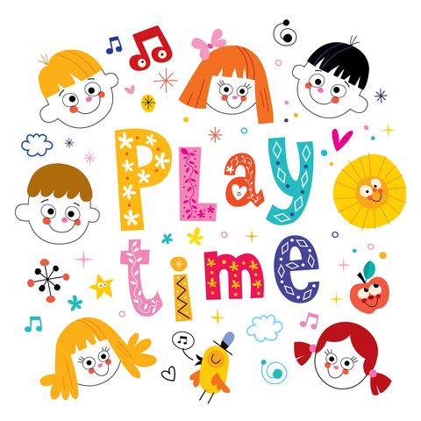

**Play time is fun.**

**We play with blocks,**

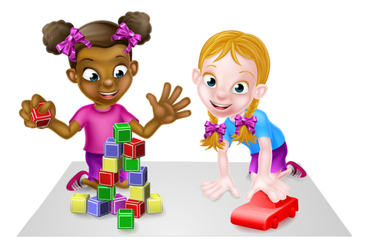

**cars,**

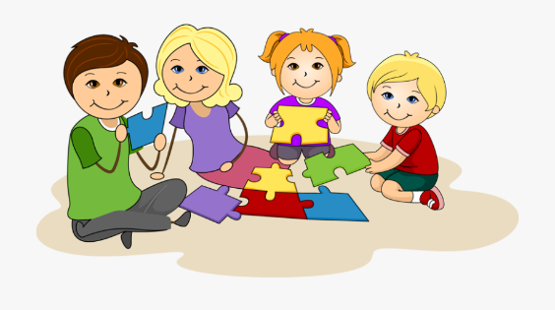**and puzzles!**

**We make pictures at the art table.**

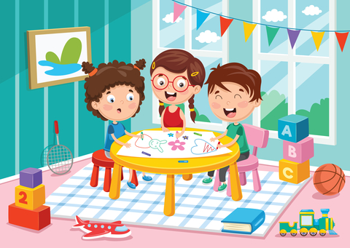**table,**

**and play games at the manipulative table.**

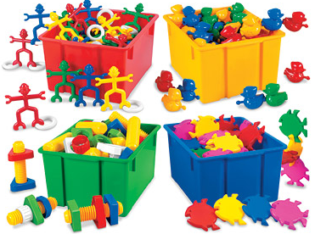

**Then the bell rings.**

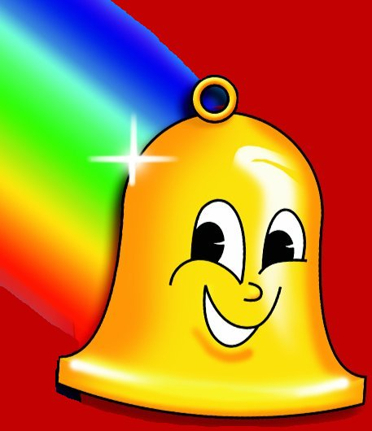

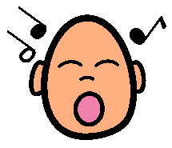

**We all sing the clean up song.**

**Clean up, clean up.**

**Everybody, everywhere.**

**Clean up, clean up.**

**Everybody do their share.**

**My teacher says,**

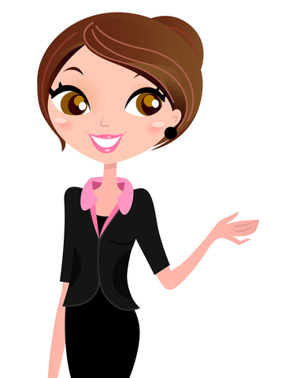

**Clean up time everybody!**

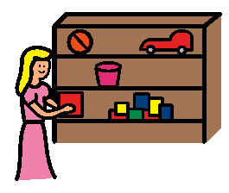**I stop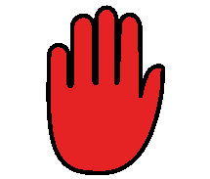what I am playing and put the toy back where it belongs.**

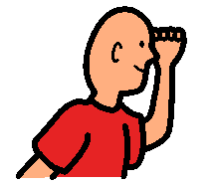 **Then I look around.**

**I see something on the table and put it back on the shelf.**

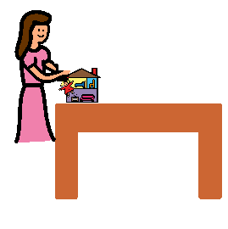

**I see something on the floor and put it where it belongs.**

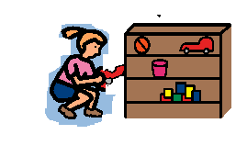

**Then I go to circle and sit on a mat.**

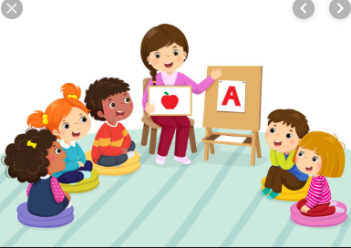

**When we work hard to clean up, 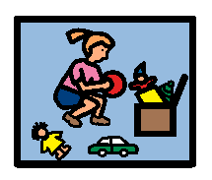our classroom stays clean,**

**and our teacher is happy!! **

**Good job!!! It is so clean in our classroom!**

Place teacher’s photo here



**It’s clean up time**

**REMEMBER:** 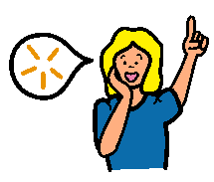

**1. STOP**

**2. LOOK **

**3. PUT TOYS ON SHELF**