

Watson Takes A Close Look At…

Classroom Centers: Visual Cues, Labeling
One key to promoting appropriate behavior and independence is to ensure children are actively and appropriately engaged in activities with materials or people (Strain, 1997). When setting up a classroom for children engagement can be promoted with a center based environment. Centers can include:
- Listening
- Language master
- Language Arts
- Book/magazine
- Play/leisure
- Art
- Writing
- Math/manipulatives
- Sensory
- Science/Social study/community
- Computer/ IPad
- Independent work stations

Having a variety of centers to include within a student’s schedule can increase appropriate behavior and independence. When developing centers for children with autism spectrum disorders, behavior disorders, attention deficit disorders, learning disabilities, or other neurological impairments;, special attention should be directed to visual cues, specifically labeling. These pictures demonstrate supportive strategies to promote independent engagement in a center based classroom.

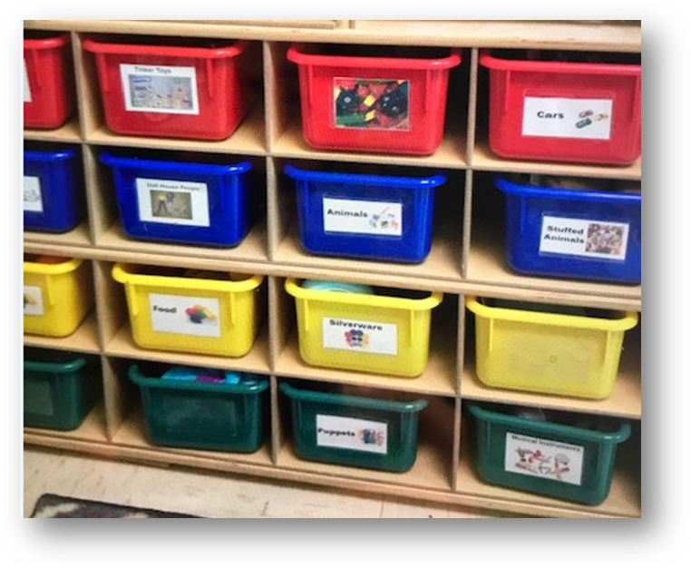
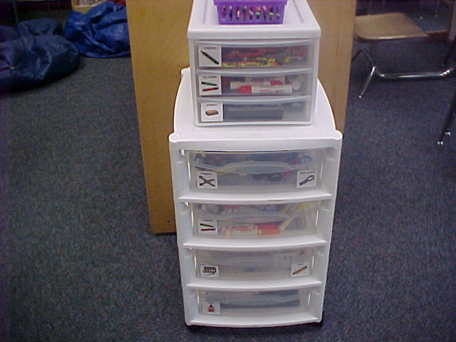

(A) (B)
Visual labeling is another good support for students with autism. Picture (A) is a play area with bins labeled with pictures and words. Picture (B) is in an art center. These tiered bins are excellent organizers for centers. This one is labeled with Mayer Johnson pictures and words. Examples include scissors, markers, paper, and crayons.

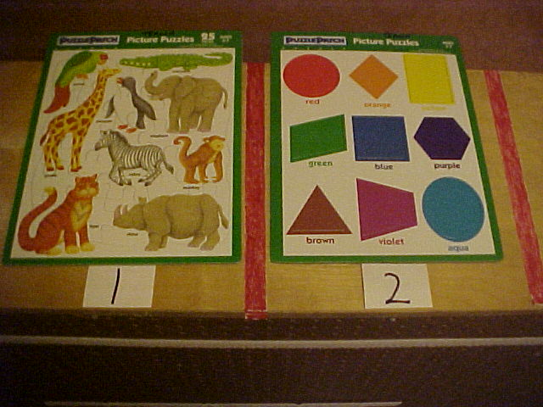

(C)

Picture (C) is a puzzle center. The typical puzzle holder was too difficult for students to use and they could not see the puzzle. Colored masking tape and numbers organize this area. The puzzles are on a shelf divider. There is a desk on one side of the divider to serve as a puzzle center. The puzzles can be labeled on the back with matching numerals so they are placed in a matching section. Numbers can be placed on a student schedule if he/she needs to choose a certain puzzle. The organization can serve as a beginning and end task.

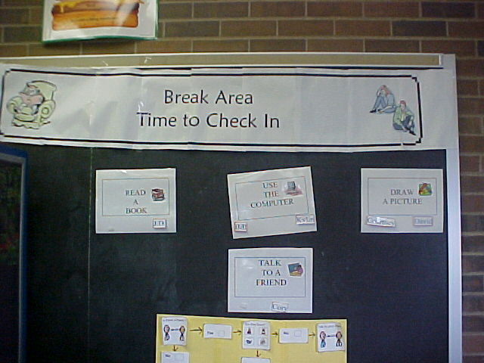
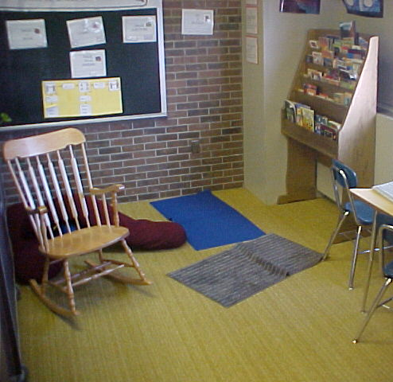

(D) (E)

Visual labeling takes a different slant in a middle school. Pictures (D) and (E) are part of a leisure center or area. Picture (D) shows visual choices and a flow chart of how to participate in a leisure center or area. The teacher- made posters say, “Use the computer”, “Draw a picture”, “Read a book”, “Talk to a friend”. They are posted right in the leisure area as seen in Picture (E). The flow chart describes when and how to talk with a peer. More visuals are used on the posters if needed by placing a student name on the poster with Velcro.

Engaging children with their environment promotes positive behavior and independence. A center based classroom is a first step to achieving this engagement. Providing visual cues such as labeling is a second step.

For more information and resources for center development access:
www.thewatsoninstitute.org/resource/centers-powerpoint/

Reviewed and Revised 7/30/2019

