Beethoven was a Great Composer and Nice Man
Beethoven wrote wonderful music. He wrote Ode to Joy. He worked VERY hard on his music so people would enjoy listening.
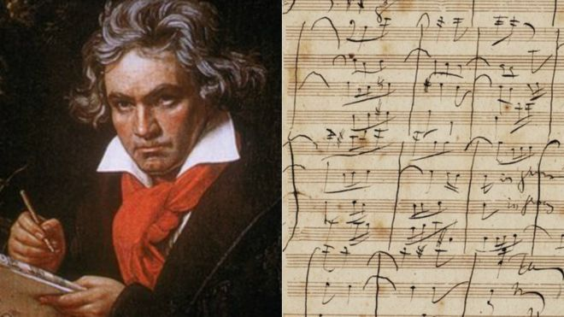

Beethoven had many teachers who knew music and helped him. He really loved his teachers. He used nice words when he talked to his teachers and other adults who helped him. He had to tell them how he felt about things. He used his words very well.

I always use nice words quietly because I liked my teachers and people who helped me.
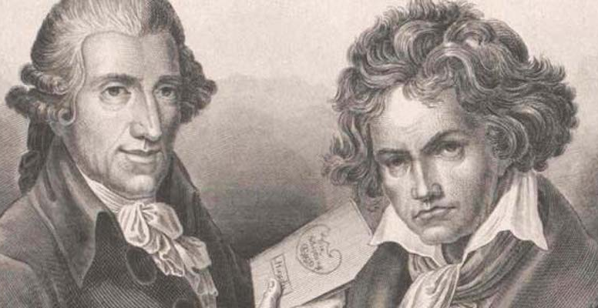

Beethoven with a favorite teacher: Haydn

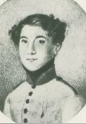
Beethoven had brothers and friends too. He was ALWAYS nice to them and used nice words. He never hit or pushed his brothers or his other children.
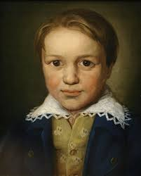
Lugwig Karl

If Beethoven was upset about something. Or if he wanted something, he ALWAYS used his words in a quiet way.
Beethoven NEVER EVER hit or pushed anyone.
I NEVER hit or push anyone! I used my words quietly. _______, try hard to NEVER hit or push. Try to never yell. That makes me sad.
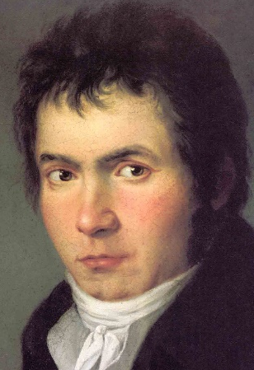

If Beethoven was sad or mad he might say:
“I’m sad. I don’t want to __________.”
“Can I take my music with me?”

If I am mad or sad I can say things like:
“I need a break right now.”
“I need help with this.”

I’m going to try and be like Beethoven. I’m going to try and use my words in a quiet way.
I am going to try hard not to hit or push. Beethoven NEVER hit. He made beautiful music like Ode to Joy and he used beautiful words in a quiet way.

Picture of student
I am trying hard to use my words quietly and NEVER HIT or push.

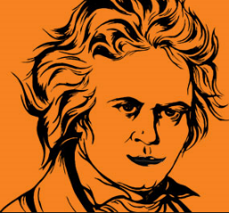
You can do it [student name]!
Remember [student name]:
Use your words. You can say:
“I am sad”
“ I don’t want to ______ “
“Can you help me?”
“I need a break.”
Be like Beethoven – NEVER HIT JUST USE YOUR WORDS

