Batman and I Go Potty!

My name is [student name]. I’m getting bigger, every day.

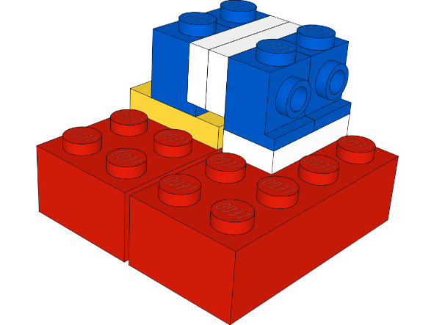 I love to build with Legos.
[Insert child’s interest]

I go to school. I have fun.

I am learning to use the potty just like Batman!
I pee & poop in the potty
Hi _____! I pee and poop in the potty too!
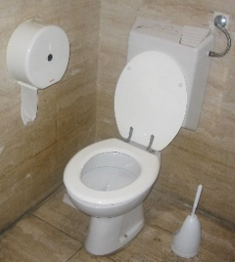

I pee in the potty now!
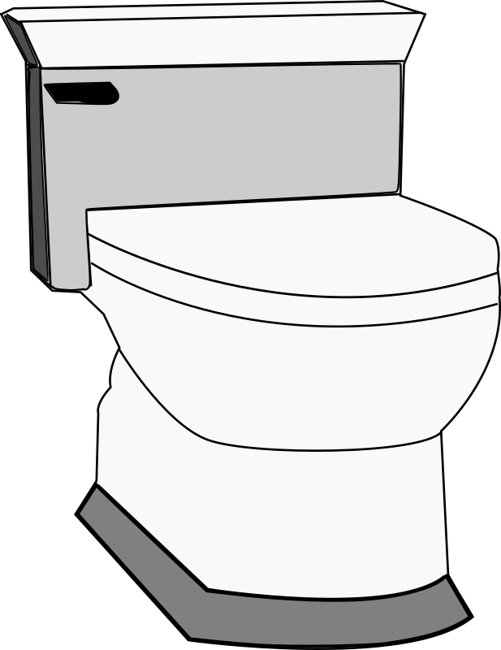

I will learn to poop in the potty too.

I will feel my tummy ready to poop.

It’s time to poop.

Here I go to the potty.
[insert pix of child sitting on potty]

Just like Batmat.
I poop in the potty.

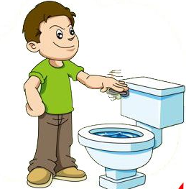
Flush!!!! I am such a big boy.
All done!!! [can insert child pix]

Good job _______!!!

First poop in the potty, then_____________________________________.

