All About Babies

Babies are so cute. They smile and laugh and play.
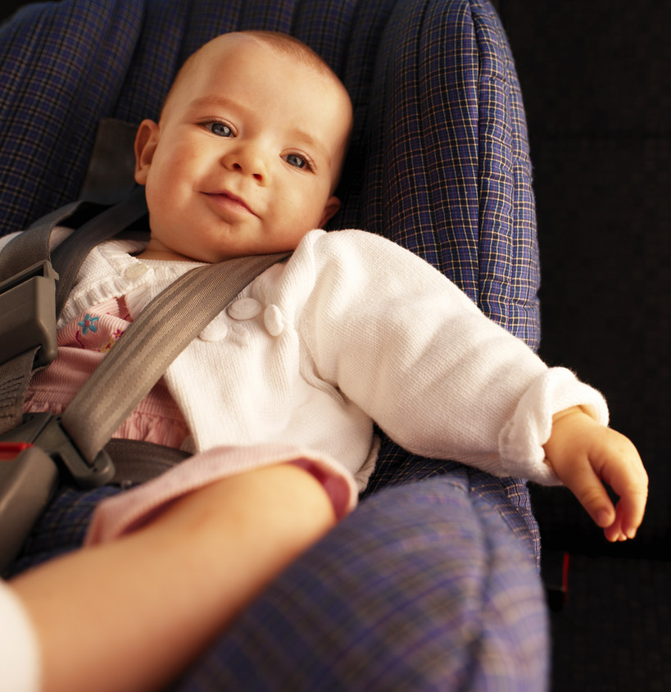

It’s fun to play with babies.
There are lots of things to do with babies. You can gently tickle a baby. Or, make a silly face at the baby…or a silly noise – sometimes that will make a baby laugh.


But, you have to be careful when you play with babies. Babies are very little and can get hurt if you are too rough.
Sometimes babies can be annoying, too. Sometimes they cry too loud.


And sometimes babies want your toys.


Babies can keep moms and dads very busy, too!
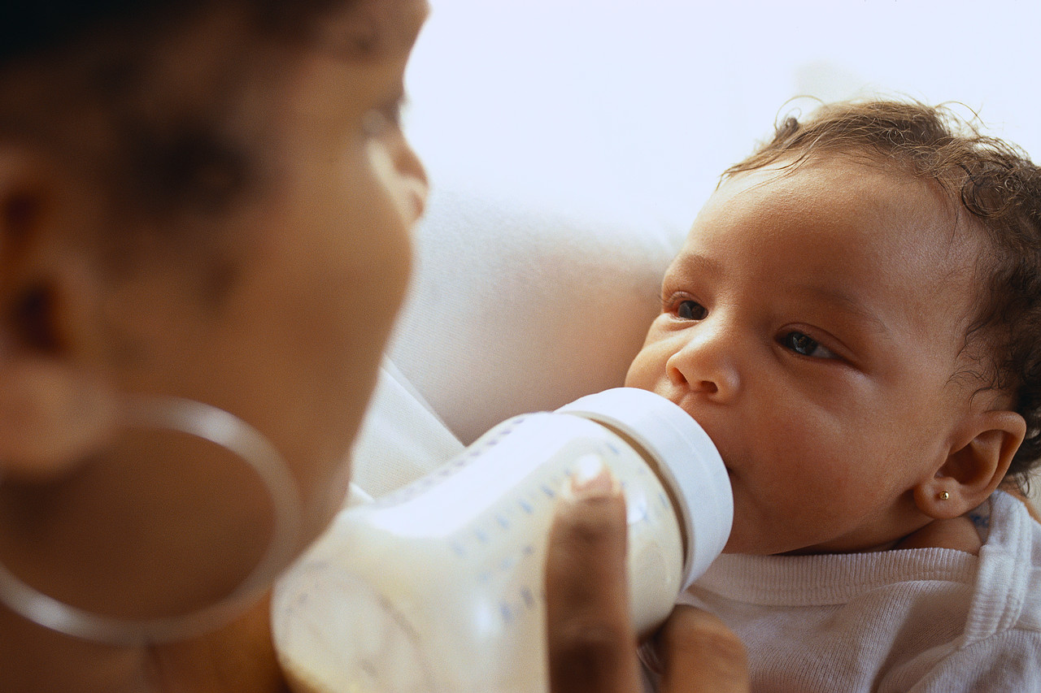

But, even when a baby is a little bit annoying, you can never, ever hurt the baby. Remember that sometimes babies can’t understand as well as you do. So, what can you do if a baby is bothering you?
- Call Mom or Dad.
- Move away from the baby.
- Give the baby a different toy.

Mom!

So, taking care of cute, little babies can be fun. But, we have to remember to be very gentle and kind.

