
A Time for Videos

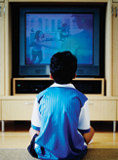

Many children love to watch videos. Children often watch videos at home.

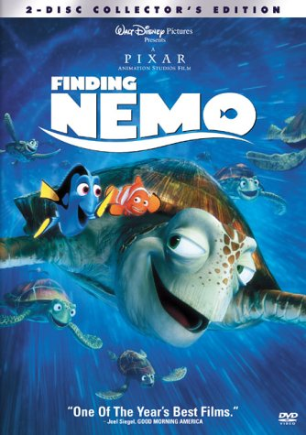
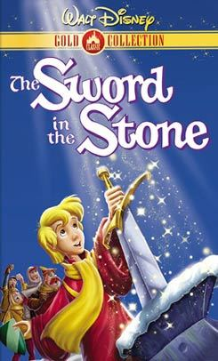

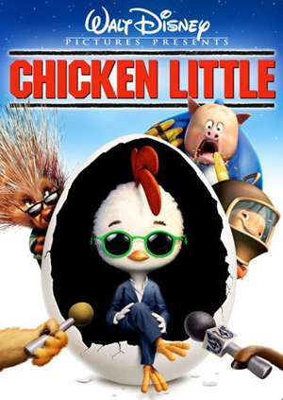

Many children have favorite videos. Some children like Finding Nemo or Sword in the Stone or Chicken Little.

It can be fun to watch the videos more than once. It can be fun to remember some of the story words and say them out loud. This could be called playing in the video world.
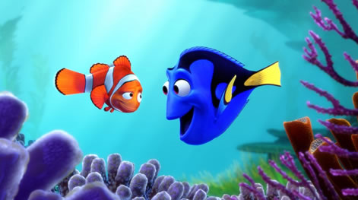

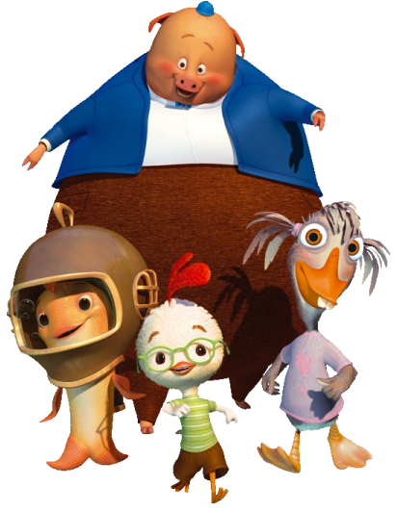
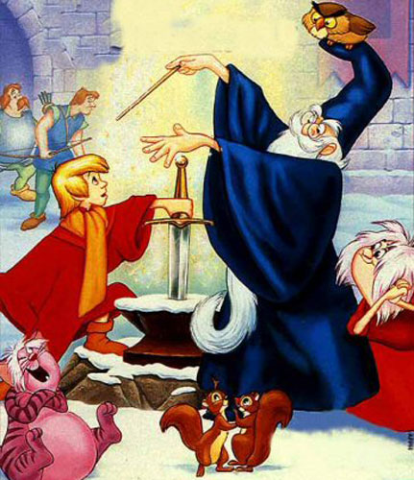

Playing in the video world is when we say the words from our favorite videos to ourselves over and over again.
“No! No! Nemo!

Go this way.

I’ll save you.”



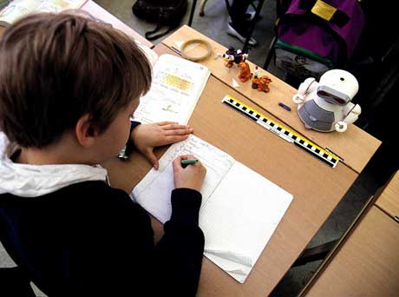

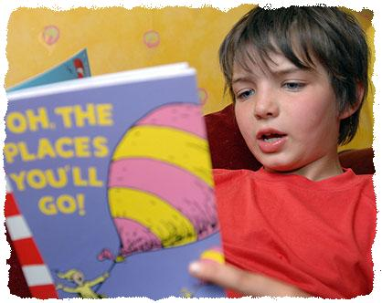

It is ok to play in the video world sometimes but not too much at school. At school children need to work on their reading and math. There should be no playing in the video world when the teachers are teaching.

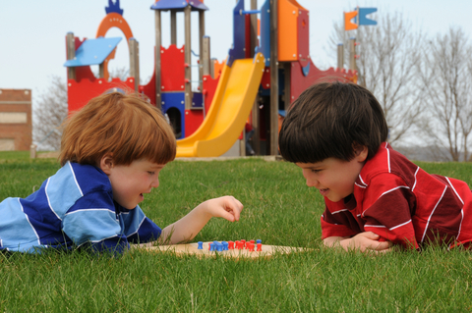

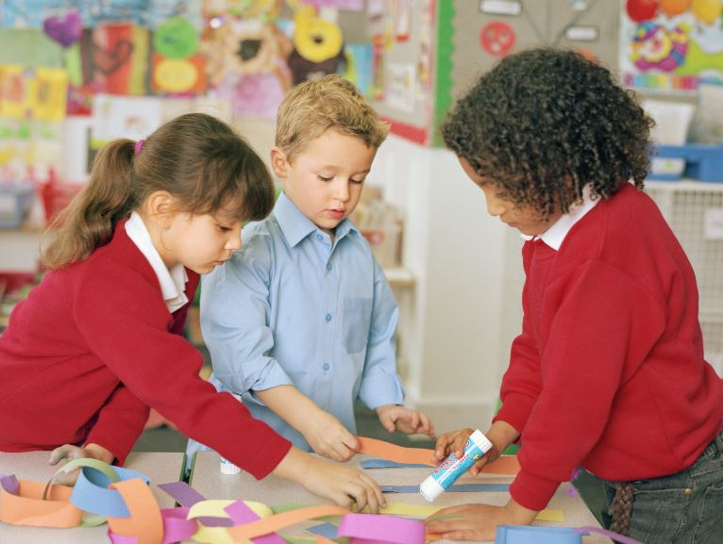

At school you learn to play with other children. There should be no playing in the video world when playing with friends.

If you want to play in the video world at school ask a teacher. You might say, “Can I play in the video world?” Your teacher might say, “Later. Now you need to do your work.”

or

Your teacher might say “OK” and set the timer. You can think about your favorite videos and say the video words. When the timer goes off, it’s back to school world. Video world is finished.
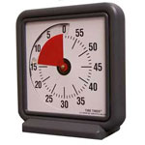

Remember it is best to play in the video world at home.

If you need to play in the video world at school ask a teacher.

If the teacher says yes, she will set a timer. When the timer goes off it is back to school world and video world is finished.


Your teachers and friends at school will be happy you are in the school world.

No Nemo

If you need to play in the video world at school:

Ask a teacher –

She might say:

“Yes, later. Now you need to do your work.”

OR

“OK” and set the timer

Remember: when the timer goes off video world is finished

