A Story About

Me,

Talking,

And

School

This story is about me, and something I like to do, just like the kids in these pictures!

My name is [student name]. I go to [school name]. One of the things I really enjoy doing is talking to other people.

I like to just walk up to an adult and talk about things that interest me. I like to ask questions.
???????????????

I like to raise my hand to answer or comment in my class.

Talking is something I like very much.

In [grade level] grade [teacher’s name’ ] asks the class questions. I like to raise my hand and answer. I like to raise my hand just to tell her things. Other kids like to answer and tell things too. [teacher’s name] cannot call on my every time. It would be good to answer or tell something to [teacher’s name] just 3 times and then STOP.
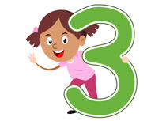

After 3 times I can start to write down what I want to say. When class is over I can ask [teacher’s name] if it is a good time to ask or tell her something.
Is this a good time to talk to you?
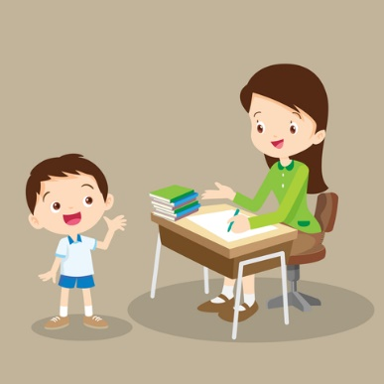

When I am in [Support Room teacher’s name] class and I want to talk to her/him or to [ list other Support Room adults], or any other adult, I need to look at them to see if they look busy.

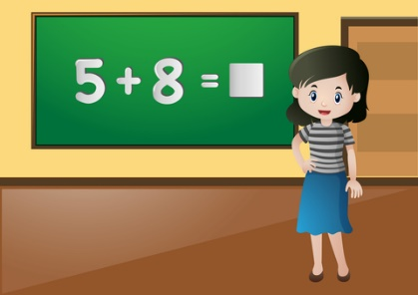
If they are teaching, that is a sign that they are busy.

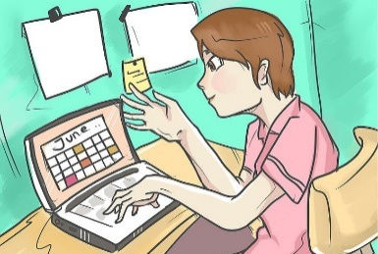
If they are getting things ready in the classroom, that is a sign that they are busy.

If they are talking to someone, that is a sign that they are busy.

If I am not sure it is alright to talk, I can say, “Excuse me, is this a good time to talk to you?” If the answer is “no” I can:
Excuse me, is this a good time to talk to you?

- Write down what I want to ask or say and pick another time
- Check my schedule to see what I should be doing
- If I’m done then do something else like draw, write a story, or make a poem

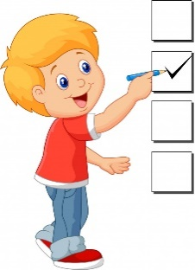

So, to summarize:
There are many things to try to do when I want to talk, AND things to try to do if I CAN’T talk. Here they are in a list.
WHEN I WANT TO TALK:
- Answer or comment only 3 times in [teacher name] class
- Write down what I want to say and pick another time
- Look to see if it is a good time to talk (are adults busy, are adults talking to someone, are they teaching)
- If I’m not sure, Ask if it is a good time to talk or
- Check my schedule
WHEN IT IS NOT A GOOD TIME TO TALK TRY TO:
- Write down questions or comments
- Draw or write a story or a poem
There are times when it is more important to listen and NOT talk. There are times when it is better to do something else and NOT talk.

