A Story About Barbie and Going to Classes

Hi! My name is Barbie! I go to a big school! Sometimes I have to walk to other classrooms.

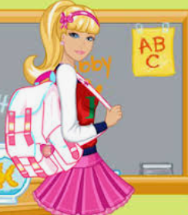

I like to walk to my other rooms and see my teachers.
Sometimes I walk to art. Sometimes I walk to gym.
Sometimes I walk to my speech class. After lunch I walk back to my room and do work at my desk.
I walked to art!
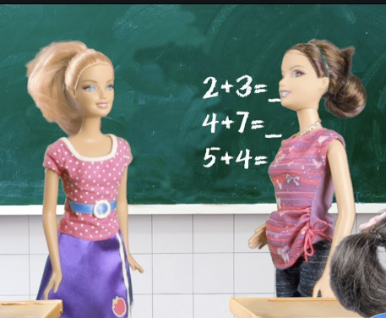
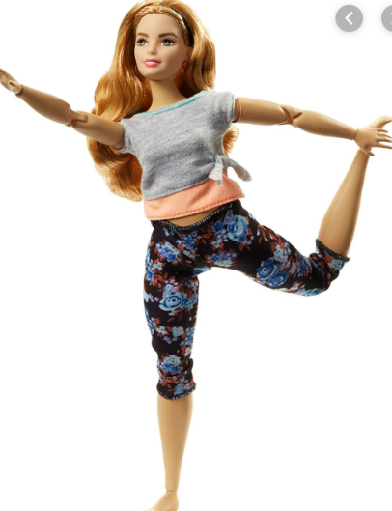
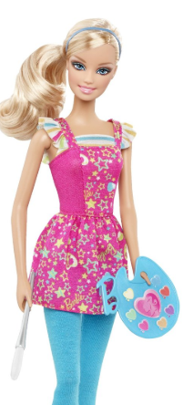
I walk to my classrooms different ways.
I walked to my room after lunch!
Hi, I just walked to class myself!
I walked to gym!
Sometimes I go with many friends from my class. This is fun to do. We all walk in the hall with a teacher. Then we go into another classroom

Sometimes I walk by myself and wave to an adult who smiles as I go. Another adult sees me coming and smiles and waves too! I like to see them because I like them.

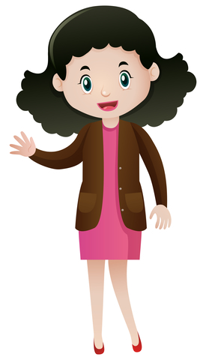

At my school we have girl’s rooms. This is really the bathroom. Sometimes I go to the Girl’s room. I go into a stall. AS SOON as I am finished I come RIGHT OUT.

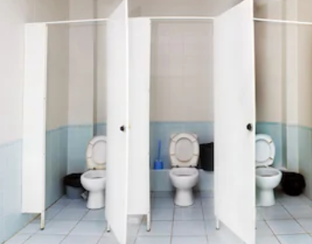
I always come right out when I’m done!

Sometimes I have to walk up steps. Sometimes I am very tired. Then I say to an adult, “I am tired. Is it OK if I sit and rest? Then I will go upstairs.” When I rest I stay in one place. When I feel better I go to my next class.

Yes, thank you for asking Barbie.
I’m tired, may I sit & rest?
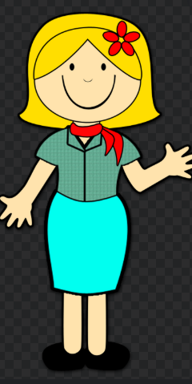
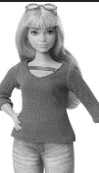
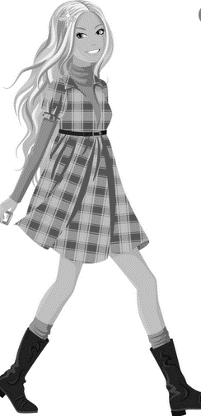
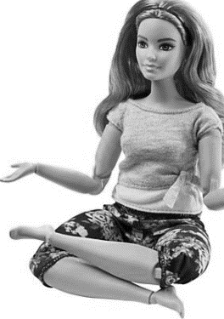
I feel better, I can go to class now.
Thank you.

Whenever I walk to places in my school I try to remember important things.
- I remember to talk nice.
- I remember the most important thing is to go RIGHT to my next class.
- I remember to stay with a friend, my class, or an adult. This is safe.
- I remember to tell an adult when I am tired and ask if I can rest.
- I remember to go to the bathroom and come RIGHT out.
I always talk nice!
I stay with a friend, or my class, or adult. Sometimes I wave.
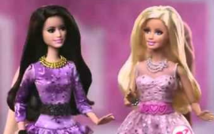
I go right to my classes!
I always ASK if I need to rest

So if you go to a school like me, try to remember to:
Talk nice
Go to you next room!
Stay with someone or wave to someone you can see.
Tell when you are tired and ask to rest.
Go to the bathroom then come right out.

___ do you try to go to your next room like me?
___ I bet you try to talk nice
____ I know you wave or stay with your friends too!

Remember ____ ask to rest like me
I bet you come right out of the bathroom like me _____!

When I do all these things… I feel just like all my friends at school. That makes me happy!
Good for you _______

