Social Skills: Parent Note

Your son/daughter just completed a social skill lesson. The topic was: Friendship Skills – Let’s All Work Together. Your knowledge of this lesson may help you to help your child generalize the skills to other environments.

What he/she learned:
- The classroom
- There are a lot of students in each class
- There is usually only one teacher
- The teacher’s job
- The student’s job
- Skills to help the student do his/her job
- What does PARTICIPATION mean?
- Working Together
- Cooperation what does it look like?
- Cooperation Activity – “Travelling Turtle” (younger students)
“Lego Models” (older students)
- So What Do You Think?
- Lesson Summary Card

Your child received a Lesson Summary magnet:
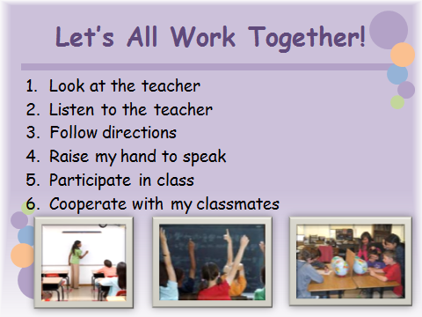
If you have a moment…
Email ___________________________ with any information that may help your child for the next lesson on ____________________________. THANK YOU!

