Social Skills – Parent Note:

Your son/daughter just completed a social skills lesson. The topic was:
Emotional Regulation Skills – Calming Down When Things Go Wrong. Your knowledge of this lesson may help you to help your child generalize the skills to other environments.

What he/she learned:

- School can be fun – what kind of things does he/she like at school?
- Usually everything is fine at school – how does he/she feel?
- Sometimes things don’t go so well – how does he/she feel?
- When upset, we need to calm down. Some strategies to try:
- Take 5 slow deep breaths
- Close your eyes
- Count slowly to 10
- Squeeze a ball
- Ask to get a drink
- Get back to having fun!

Your child received a Lesson Summary magnet:

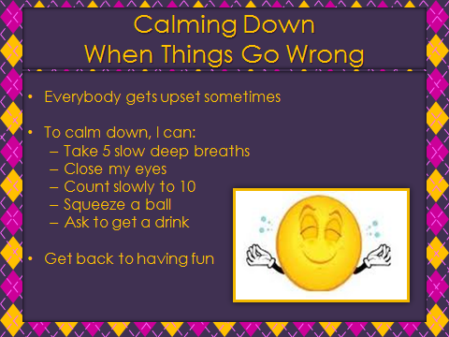

If you have a moment…

Email ___________________________ with any information that may help your child for the next lesson on ___________________________. THANK YOU!

