**Who Is Being a Good Sport?**

**Circle the pictures that show people being good sports. Talk about why you circled them.**

**Talk about why you didn’t circle the other pictures.**

[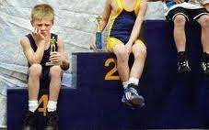](http://images.google.com/imgres?q=poor+sportsmanship&hl=en&gbv=2&biw=1600&bih=728&tbs=itp:photo&tbm=isch&tbnid=3g4Qc-LI04T-MM:&imgrefurl=http://luizruiz.wordpress.com/2011/05/16/sportsmanship/&docid=1ro31K6pzZCDVM&imgurl=http://luizruiz.files.wordpress.com/2011/05/images.jpeg&w=284&h=178&ei=TRUHUMbdJKGj6wG1zKjqCA&zoom=1&iact=hc&vpx=1326&vpy=425&dur=1803&hovh=142&hovw=227&tx=77&ty=59&sig=102585700041835249895&page=3&tbnh=142&tbnw=227&start=52&ndsp=27&ved=1t:429,r:19,s:52,i:328)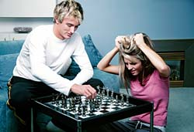[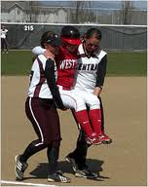](http://images.google.com/imgres?q=poor+sports&hl=en&gbv=2&biw=1600&bih=728&tbs=itp:photo&tbm=isch&tbnid=TJW5IH3QsTk4XM:&imgrefurl=http://newsconference.blogspot.com/2008_04_01_archive.html&docid=P5Kc8Idz0Q30HM&imgurl=http://graphics8.nytimes.com/images/2008/04/30/sports/sporting190.jpg&w=190&h=240&ei=XhkHUMX6B4em6gGt9_TtCA&zoom=1&iact=hc&vpx=605&vpy=422&dur=2735&hovh=192&hovw=152&tx=75&ty=114&sig=102585700041835249895&page=2&tbnh=168&tbnw=133&start=22&ndsp=28&ved=1t:429,r:9,s:22,i:175)

[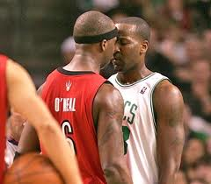](http://images.google.com/imgres?q=poor+sportsmanship&start=106&hl=en&gbv=2&biw=1600&bih=728&addh=36&tbs=itp:photo&tbm=isch&tbnid=f2ldCAwkgUGuBM:&imgrefurl=http://www.connect06.com/tag/celtics-poor-sportsmanship/&docid=OUuIRotbZktdHM&imgurl=http://www.connect06.com/wp-content/uploads/2011/01/Celtics-Thug-Player-Kendrick-Perkins-Starting-Trouble-Again-in-the-NBA.jpg&w=315&h=275&ei=cBUHUJXjLMqo6wGzrd26CA&zoom=1&iact=hc&vpx=372&vpy=170&dur=586&hovh=210&hovw=240&tx=112&ty=98&sig=102585700041835249895&page=5&tbnh=168&tbnw=192&ndsp=26&ved=1t:429,r:7,s:106,i:114)[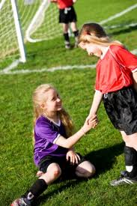](http://images.google.com/imgres?q=good+sports&hl=en&gbv=2&biw=1600&bih=728&tbs=itp:photo&tbm=isch&tbnid=Ikj6eQIVbAK3JM:&imgrefurl=http://blog.parents-choice.org/%3Fp%3D1595&docid=uSvWIBL5VI8ofM&imgurl=http://blog.parents-choice.org/wp-content/uploads/2011/06/importance-of-good-sportsmanship-post.jpg&w=300&h=449&ei=3RkHUNf4H6Wf6wGAsfDOCA&zoom=1&iact=hc&vpx=326&vpy=182&dur=837&hovh=275&hovw=183&tx=106&ty=153&sig=102585700041835249895&page=1&tbnh=144&tbnw=105&start=0&ndsp=21&ved=1t:429,r:1,s:0,i:93)

