This week I might try:

To Learn from Losing

I’ll try to remember that there are things I can learn from a game, even if I lose. I can learn to show the winner that I am a good sport. I can learn to use self-control and calm down when I’m upset. And I can learn to keep trying and do my best when I’m playing a game.

I can keep track of what I’m learning on the chart below:

This week: | Day  1 | Day  2 | Day  3 | Day  4 | Day  5
I showed the winner that I was a good sport.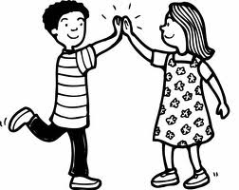

I used self-control to calm down when I was
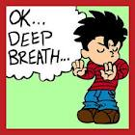
upset.

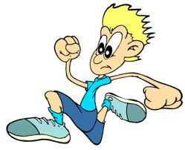
I kept trying and did my best when I was playing a game.

Some good ways to calm down are:
Take a deep breath
Squeeze my hands together
Count slowly to 10

