Social Skills – Parent Note

Your son/daughter just completed a social skills lesson. The topic was:
Friendship Skills – I Can Learn From Losing. Your knowledge of this lesson may help you to help your child generalize the skills to other environments.

What he/she learned:

- Playing games are fun and everyone likes to win, but usually only one person/team can win.
- It’s OK to lose because we can learn from losing.
- We can learn three things:
- to be a “good sport”
(high fives, shake hands, say
“good game”
- to use “self-control”
*These phrases were defined, discussed and practiced with the students.
(take deep breaths to calm down;
practice in real situations)
- to “keep trying”
(important not to give up; try
your best)

Your child received a Lesson Summary magnet:

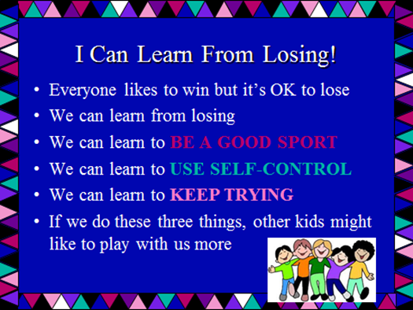

If you have a moment, email _____________________________ with any information that might help your child for the next lesson on ________________________. THANK YOU!!

