Social Skills – Teacher Note:

Your student just completed a social skill lesson. The topic was:
Friendship Skills – Having Fun at Recess. Your knowledge of this lesson may help you to help your student generalize the skills to other environments.

What he/she learned:

- What kids do at recess

- What kinds of problems can happen at recess

- What to do if he/she:

- doesn’t know what to play
- wants to join in
- doesn’t know how to play

- Things to say to kids on the playground

Your student received a Lesson Summary magnet:

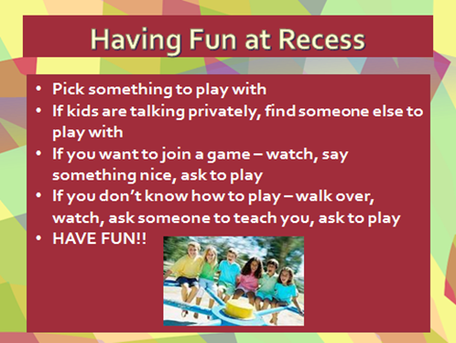

If you have a moment…

Email ________________________________ with any information that may help your student for the next lesson on __________________________. THANK YOU!

